Voting Down Road Maintenance: The Fiscal Illusion of Local Tax Relief and House Values

June 19, 2026

Abstract
Local governments often finance infrastructure maintenance through recurring taxes that are renewed by voters periodically. Utilizing a quasi-experimental setting, we study what happens when voters narrowly reject dedicated road-maintenance funding. Using 3,184 Ohio renewal referendums from 1991 to 2021, we compare jurisdictions just above and below the 50 percent cutoff in a dynamic regression discontinuity design. A failed renewal removes an existing revenue stream that costs households about $76 per year and equals about 11% of local road-maintenance spending. Narrow failures produce delayed housing-market losses: median sale prices fall by about $15,350, or 9%, over the decade after the vote, with losses emerging after year four. Road imagery classified with a fine-tuned vision model shows post-election road-quality declines of up to 16%. Price effects are larger in urban areas, for higher-value houses, and after larger levy failures. A benefit-cost assessment implies a net loss to households of about
$1.4 for every dollar of forgone road-maintenance funding.
Keywords: Road Maintenance; Local Public Finance; Housing Values; Infrastructure; Regression Discontinuity.
JEL Codes: R42, H71, R31, C21

Introduction

The United States has about 4.2 million miles of public road, and roughly three-quarters of it—some 3.2 million miles—is owned not by states but by local governments (Federal Highway Administration, 2022). Keeping this network drivable is expensive and chronically underfunded: state and local governments spend roughly $206 billion a year on highways and roads, yet only 44% of it goes to operations and maintenance rather than new capacity (Urban Institute, 2021). The bill for deferring upkeep is mounting. The 2025 ASCE Infrastructure Report Card grades the nation’s existing roads a D+, with 39% of roads in poor or mediocre condition and a projected $684 billion funding gap over the next decade (American Society of Civil Engineers, 2025), even as the federal gasoline tax that backstops the Highway Trust Fund has held at 18.4 cents per gallon since 1993 (Peter G. Peterson Foundation, 2024). In a mature road network, the binding fiscal choice is increasingly not whether to build, but whether to maintain.
A great deal of existing research has focused on the effects of new roads¹, especially in developing nations, providing valuable policy insights and spurring development initiatives like China’s Belt and Road Initiative (Huang, 2016) and India’s Pradhan Mantri Gram Sadak Yojana (Asher and Novosad, 2020). However, the endogenous selection of these projects makes it difficult to separate the effects of new roads from the underlying economic conditions that motivated their construction, as infrastructure investments are not exogenous events but are deliberate policy choices. New road placement is selected by policymakers
and may be endogenous to anticipated economic growth, unobserved local characteristics, or uncontrolled political factors. Moreover, in mature economies with extensive road networks, the central policy question is often not where to build new roads but how to maintain existing ones.
¹See Ghani, Goswami and Kerr (2016), Beenstock, Feldman and Felsenstein (2016), Levkovich, Rouwen-
dal and Van Marwijk (2016), Hoogendoorn et al. (2019), Theisen and Emblem (2021), Gibbons et al. (2019), Fretz, Parchet and Robert-Nicoud (2022). Some papers have also observed adverse effects of new roads such as state-led repression (Gonz´alez et al., 2025) and environmental degradation (Asher, Garg and Novosad, 2020).

In this paper, we avoid endogeneity issues by studying property taxes that fund the maintenance of existing roads and by utilizing a quasi-experimental setting that arises from analyzing close elections. We assemble a panel of 3,184 road-tax renewal referendums in Ohio from 1991 to 2021 and link the election records to financial records of local governments, CoreLogic house-sale transactions, community characteristics, and satellite imagery of local roads. Our empirical strategy compares jurisdictions where road-maintenance renewals narrowly fail with jurisdictions where they narrowly pass, using vote threshold to identify local fiscal shocks² (Cellini, Ferreira and Rothstein, 2010; Biasi, Lafortune and Sch¨onholzer, 2025). The running variable is the share of votes against renewal, and treatment occurs when that share exceeds the 50% threshold. Because renewal elections are scheduled by the expiration of prior levies rather than by a new discretionary investment proposal, close elections isolate
local effects of losing an existing maintenance revenue source. Using our rich data, we first estimate the expected loss in the road maintenance budget for a local government after a tax cut from a failed renewal of road maintenance levy. Next, we estimate the effect of cutting local road maintenance taxes on housing prices. Finally, to understand the underlying channel, we fine-tune an Artificial Intelligence (AI) vision model using more than 53,000 satellite images from Brewer et al. (2021) to predict changes in road quality after a road maintenance tax cut.
Our empirical findings reveal that when a jurisdiction cuts its renewal road maintenance taxes, an average household saves about $76 per year and the local government faces an 11% loss in maintenance funds, its house prices decrease by around $15,350 (9%) and road quality declines by up to 16% in the precisely estimated post-election windows. In rolling 3-year post-election windows, we find little immediate road-quality response in years 1 to 3 after the vote, followed by statistically significant deterioration in years 2 to 4 and continued strong negative effects in years 3 to 5. A simple benefit-cost comparison shows that for each dollar of road-maintenance revenue voters forgo, households incur a net loss of $1.4.
²Grosz and Milton (2025) study the effects of changes in these voting thresholds.

We provide suggestive evidence on that mechanism using road imagery and a fine-tuned vision model that classifies road-surface quality. The imagery evidence shows no meaningful pre-election discontinuity in road quality. Post-election road-quality scores fall by 8 to 10 RQS points in the most precisely estimated delayed windows, roughly 13% to 16% relative to the pre-election mean. Taken together, the evidence is consistent with a channel in which failed renewals reduce available maintenance funding, which may lead to gradual declines in road quality and, over time, to reductions in house prices once deterioration becomes salient.
The distribution of effects also matters for policy. The price declines are concentrated in urban jurisdictions and are larger for higher-value houses and larger levy failures. We interpret these patterns as evidence about incidence and capitalization rather than as direct evidence about household wealth or welfare. Sellers in affected markets may bear capitalized losses, buyers may benefit from lower purchase prices while inheriting lower service quality, and although current taxpayers receive short-run tax relief, these savings are eclipsed by the long-run decline in local asset values. The results therefore highlight this public finance trade-off and document the effects of public disinvestment decisions on local asset values.
The paper contributes to three strands of research. First, we extend work on infrastructure and housing markets from new construction toward the maintenance of existing public infrastructure. By exploiting close elections for renewal levies earmarked to fund road maintenance, we mitigate endogeneity concerns and estimate the capitalization of road maintenance decisions on local house prices. Second, we contribute to the local public finance literature by showing a striking example of salience-induced fiscal illusion, where voters in some local governments choose small but immediate tax savings at the cost of housing wealth destruction that only appears years later.
Third, we demonstrate how scalable remote-sensing measures can help evaluate public infrastructure policies where administrative road-condition data are unavailable or inconsistent.
The rest of the paper proceeds as follows. Section 1.1 positions the study in the literatures

on infrastructure, capitalization, and road-quality measurement. Section 2 describes Ohio’s local road-finance institutions, the renewal elections, the housing data, and the road-quality measure. Section 3 presents the dynamic regression discontinuity design and the identifying assumptions. Section 4 reports house-price, road-quality, heterogeneity, and robustness results. Section 5 discusses policy mechanisms and interpretation, and Section 6 concludes.

Literature

This paper connects three lines of research: infrastructure capitalization, local public finance, and the measurement of infrastructure quality. The common thread is that households do not buy homes separate from the local public-service bundle. Along with a house, they buy access to a jurisdiction’s taxes, services, and expected public infrastructure maintenance choices. Consequently, road-maintenance renewal elections are both fiscal decisions and housing-market signals.
Infrastructure and house values. A large literature studies how transportation infrastructure affects local housing markets. Much of this work focuses on new infrastructure or major upgrades. For example, Gonzalez-Navarro and Quintana-Domeque (2016) studies randomized street paving in Mexico and finds large increases in property values, while Theisen and Emblem (2021) and related work estimate capitalization effects from new or improved transportation access (Dub´e, Legros and Devaux, 2018). These studies are important, but they address a different policy margin than the one facing many U.S. local governments. In mature road networks, the central question is often not where to build a new road but whether to preserve existing roads before deferred maintenance becomes costly and visible.
The maintenance margin is less studied, especially for local roads in developed economies. Gertler et al. (2024) examines highway maintenance in Indonesia and finds that better road quality affects local economic activity and housing prices. The classic capitalization study of Edel and Sclar (1974) examines local public spending and house values in the Boston area

but predates modern quasi-experimental designs and high-frequency administrative housing data. Our contribution is to study local road maintenance in a setting where existing revenue streams are periodically renewed or cut by voters and where close elections provide quasi-experimental variation.
Local public finance and ballot-box decisions. The local public finance tradition emphasizes that property values capitalize local taxes and public services (Oates, 1969, 1972). Recent work on local tax relief has documented the immediate capitalization effects of property tax cuts (Moulton, Waller and Wentland, 2018), but it has not focused on the long-term effects of cutting dedicated maintenance funding. Renewal levies make this trade-off explicit. If voters renew a levy, they continue paying a dedicated tax and preserve maintenance funding. If they reject it, they receive near-term tax relief but reduce the local government’s capacity to maintain a public asset. This setting is related to the use of referendum discontinuities in public finance, including Cellini, Ferreira and Rothstein (2010), but differs in an important way: we study renewals for existing maintenance rather than new capital spending. Renewal timing is set by the expiration of prior levies, which helps separate the maintenance-funding shock from the endogenous timing of new investment proposals.
Measuring road quality. A key challenge to evaluating infrastructure policy is measurement. Engineering measures such as the International Roughness Index and Pavement Condition Index can be costly, irregular, and unavailable for many local roads. Currier, Glaeser and Kreindler (2023) shows how vertical-acceleration signals can be used to construct road-roughness measures in places with sufficient platform coverage, while Wong et al. (2017) relies on standardized field surveys to measure road quality in rural China. Our approach is different and complements these existing methods. We fine-tune a vision model on labeled road samples to construct consistent road-quality measures for Ohio jurisdictions. This approach allows us to build a panel of road images to observe whether lost maintenance revenue is followed by road deterioration.

Background & Data

Policy Setting: How are Local Roads Funded in Ohio?

The policy setting is useful because renewal levies connect a concrete household tax bill to a dedicated local maintenance service. Voters are not deciding whether to start an unusually large capital project; they are deciding whether to continue an existing revenue stream for the upkeep of roads already in place. This section describes the institutional details needed to interpret those votes and the data used to measure their consequences.
Roads in Ohio are funded through a combination of federal, state, and local sources. A significant portion of road funding provided by federal and state governments comes from gas taxes, which are currently set at $0.18 per gallon for the federal tax and $0.38 per gallon for the Ohio state tax. Additional sources for these two levels of government include vehicle registration fees, license plate fees, tolls, and driver’s license fees. Funding for local governments largely comes from property taxes. Below, we provide an overview of road funding in Ohio from national, state, and local sources.
Federal Funding. U.S. Department of Transportation provides funding for road infrastructure through the Federal Highway Administration (FHWA). The FHWA provides funding for the construction, maintenance, and operation of highways, bridges, and tunnels. The federal government provides funding for road infrastructure through the Highway Trust Fund (HTF), which is funded by the federal gas tax. The HTF is divided into two accounts: the Highway Account and the Mass Transit Account. The Highway Account is used to fund highway construction and maintenance, while the Mass Transit Account is used to fund public transportation projects. The federal government also provides funding for road infrastructure through the Surface Transportation Block Grant Program or Bipartisan Infrastructure Law (U.S. Department of Transportation, 2022), which provides funding for road projects that are not eligible for funding through the HTF. Nevertheless, federal government funding for road infrastructure is generally limited, as in 2022, about 4/5th of

all funding came from state and local governments (Peter G. Peterson Foundation, 2024).
State Funding. In Ohio, gas taxes, licensing fees and user fees account for 69% of the state’s road funding (Boesen, 2021). The Ohio Department of Transportation is responsible for the allocation of state funds, which are used for both maintenance and new construction. However, about 70% of funds goes to new highway construction, 2% is given to local governments as grants and only 4% of state funds are directed towards road maintenance (Ohio Department of Transportation, 2023). The remaining funds are part of payroll and operating expenses and other miscellaneous expenses. Hence, most of the road maintenance funding for local, neighborhood-specific roads in Ohio comes from local governments.
Local Funding. Local governments in Ohio fund roads mainly through property taxes, although the extent of this funding varies across different localities. These municipalities have the authority to levy property taxes specifically for road maintenance, providing a crucial source of funding for the upkeep of local infrastructure. For instance, as per our correspondence with Beavercreek Township, 61% of its road funds come from property taxes, and only 8% from gas taxes. Moreover, 77% of funding for roads in Beavercreek Township is provided by the local government and 11% of the overall local government budget is allocated to roadway maintenance (Public Service Department of Beavercreek Township, 2025). Local roads are primarily funded by local governments in Ohio and road maintenance funding is a significant part of the local government’s budget.

Local Taxation in Ohio

Background. Ohio consists of 88 counties, each covering about 464 square miles³. Each county was historically divided into about 15 equally-sized townships, which do not cross county lines. Citizens can petition to incorporate as a village, which has a different type of government structure than a township and the ability to levy both income and property taxes, whereas townships may only levy property taxes. When a village exceeds 5,000 population
³This is roughly 1,200 square kilometers.

in Ohio, it is reclassified as a city. Villages and cities may cross township and county lines, dissolve, or annex parts of contiguous townships. Villages, cities and townships, which we call “cities” for brevity, are the most local governmental unit in Ohio. Each local government covers about 18.2 miles² (47.1 km²) on average. The Ohio Revised Code (ORC) separates property taxes into unvoted and voted levies. Local governments can levy unvoted property taxes up to 1% of the assessed value of property without voter approval. Beyond this limit, local governments must seek voter approval through tax levies. These levies can be for new taxes or for the renewal of existing taxes, and can be earmarked for specific purposes such as building a new school, funding police and fire departments, or maintaining local roads. We focus on renewal levies slated for road maintenance. Our data on renewal road tax levies include 3,184 referendums and cover 617 local governments in Ohio.
The type of tax levy we study is for the renewal of road tax levies. Most of the renewal taxes we consider have stated purposes of “road and bridges repair”, “road repair”, “street fund”, and “street improvements”, although there are less common stated purposes like “repair and maintenance of streets and sewers system” and “resurfacing and rehabilitation of city streets”⁴. The construction of new roads and bridges, in contrast, would be funded with a tax levy for additional money, not a renewal tax; and it would likely be funded by a bond levy lasting 20 or 30 years.
Our dataset includes tax levies such as a 2-mill, 5-year renewal in Adams Township (Champaign County) in 1995; a 3-mill, 5-year renewal in Lore City Village in 2016; and a 2.5-mill, 5-year renewal in Pataskala City in 2007.
Renewal levies. Levies that had originally passed typically expire, and the most common duration to collect a levy is five years, representing about 90% of the road tax levies in our sample. When a levy expires, voters have the option to renew it or let it lapse. If a tax levy is renewed, taxes and funding from that revenue stream continues. If 50% or fewer votes approve the levy, it fails. When a tax levy for additional funding fails, there is no
⁴These purposes are as per the financial reports of the local governments.

increase in funding, but existing funding from other tax levies continues as normal. When a renewal tax levy fails, funding from that tax levy stops. 99% of the road tax levies in our sample are property taxes⁵.
Most RD studies that use voting data to look at the impact of funding changes examine
new tax levies for additional funding. Cellini, Ferreira and Rothstein (2010) observes that votes for additional tax money may not be statistically independent; a vote may be proposed until it passes. We minimize this source of endogeneity of new votes by only considering renewal votes (Brasington, 2017). While a government may choose when to put a vote for additional funding on the ballot and keep proposing the new tax until it is passed, when a vote passes, it has an expiration date. So if a road tax levy for additional funding passes in 2007 to last five years, in 2012 voters will have the chance to renew or reject the tax. The timing of the vote in 2012 is not endogenous, having been set in 2007. If voters renew it in 2012, it will be up for renewal again in 2017. The exogeneity of the timing of a renewal tax levy contrasts with the timing of new taxes for additional money as explained by Cellini, Ferreira and Rothstein (2010) because local governments can endogenously choose the timing of a new tax levy to coincide with positive economic conditions or positive sentiment toward government action, making an election more likely to pass.
Spending impact of failing to renew a levy. When a renewal tax levy fails, the local government loses the funding from that tax levy. The local government may still have tax levies for other purposes in effect, but the road tax levy that failed to renew is no longer collected. We determine the dollar amount in consideration when a household is making a decision on whether to vote for or against a renewal road tax levy, and we call it Average Road Tax per household, which is the tax amount that a household will pay if the levy is successfully renewed. Average Road Tax per household is computed following Equation 1:
⁵The remaining 1% are income taxes.

Average Road Tax per householdit = millage rateit × Average Assessed valueit (1)

where i is the city, t is the year, and millage-rate⁶ is the predetermined millage amount set for the road tax levy. The Average Assessed value is 35% of the average appraisal value⁷, which for our study equals the average sale price of houses in the city for that year. From this, we can also compute the average road tax per city by multiplying the average road tax per household with the number of households in the city.
Although we acknowledge a large variation in the appraisal value across cities and in millage rates across referendums, we find that the average road tax per household is $76, and the average road tax per city is $167,011 as shown in Table 1. We do not observe any significant difference in the average road tax per household between cities that renew and cut road tax levies, which suggests the levies up for renewal are not systematically different between areas that renew and areas that fail to renew them. Whenever a renewal tax levy fails, the local government loses the funding from that tax levy, which is the average road tax per city. This loss in funding directly impacts local government’s spending budget needed to maintain local roads in Ohio and accounts for 11% of a local government’s budget for road
maintenance⁸.

⁶Millage-rate is property tax rate expressed in mills (tax per $1,000 of assessed value).
⁷Assessment ratio of 35%, as set by Ohio Department of Taxation (2020).
⁸For townships within our effective bandwidth, we use the average expenditure by the public works department as our base, which is $1,528,404 as per their audited financial reports. All local roads in such municipalities are funded via this department. Average loss in maintenance spending for areas that cut their renewal levy is $163,547, thus giving us 11% = ^{163,547} × 100
1,528,404

Table 1: Spending impact of failing to renew a Road Tax Levy

Aggregate Renewed Cut

Panel A: road tax per household
Mean 76 75 79
(55) (53) (62)

Panel B: road tax per city
Mean 167,011 167,648 163,547
(340,268) (340,628) (338,671)

Notes: This table presents descriptive statistics for two measures of the money collected via road tax levies. Panel A reports the mean and standard deviation (SD) of the road tax per household per year. Panel B reports the mean and SD of the total road tax collected per city. “Aggregate” denotes the full sample, while “Renewed” and “Cut” refer to levies that were renewed and failed to renew respectively. All monetary values are in constant 2010 U.S. dollars and rounded to the nearest integer.

Running Variable

The running variable plays a critical role in RD, which in this study represents the proportion of votes against the renewal of a road tax levy. A vote share of 50% or more against the renewal road tax levy means the levy fails and the tax will no longer be collected, resulting in a stoppage of road funding via that particular tax levy. There are 3,184 referendum results in our sample, 83% of which renew the tax, and 17% of which cut taxes and road maintenance. The Great Financial Crisis falls in the middle of our dataset, so readers might wonder if voting behavior was affected, but we find vote share the same to two decimal points during and outside the years 2008-2009. Our key identification assumption is that

the election results are not predetermined and vote share is not precisely manipulated to fall just above or below the cutoff. This assumption allows us to exploit the randomization around the cutoff and provides the variation needed to identify the causal effect of cutting road tax. We test this assumption using a density test detailed below and covariate balance tests (see Appendix C).
Density test. A classic RD assumption states that agents cannot precisely manipulate the running variable to fall just above or below the cutoff. In our context, it means that the election results are not determined prior to when the ballot takes place. In other words, no individuals, organizations, higher levels of government, foreign governments, or the firm that programs the voting machines are dictating the precise vote share for the renewal road tax levy referendums raised by a city. The standard way to test this assumption is to perform a density test like that of Cattaneo, Jansson and Ma (2020), which is based on the idea that manipulation of elections might cause a clustering of votes just to one side of the cutoff, with a pronounced drop-off on the other side of the cutoff. The p-value of this density test is 0.98. A histogram of vote share is shown in Figure 1 that graphically illustrates the lack of abrupt change in density.
Although Table 3 shows covariate balance between sets of cities that pass and fail to renew road tax levies, covariate values could still jump from one side of the cutoff to another. A drop in education levels, for example, could cause a drop in house prices that might coincide with a change in treatment, so that what might look like a treatment effect from cutting taxes and spending might in fact be caused by lower education levels. Graphs that suggest covariate smoothness around the cutoff are found in Appendix C. A formal way to assess covariate smoothness is to use each covariate as an outcome variable in a regression of the running variable and the treatment effect dummy. When we do so, the p-value of the treatment effect dummy varies from 0.234 to 0.981, as shown in Table 13, indicating no statistically significant jump in covariate values.

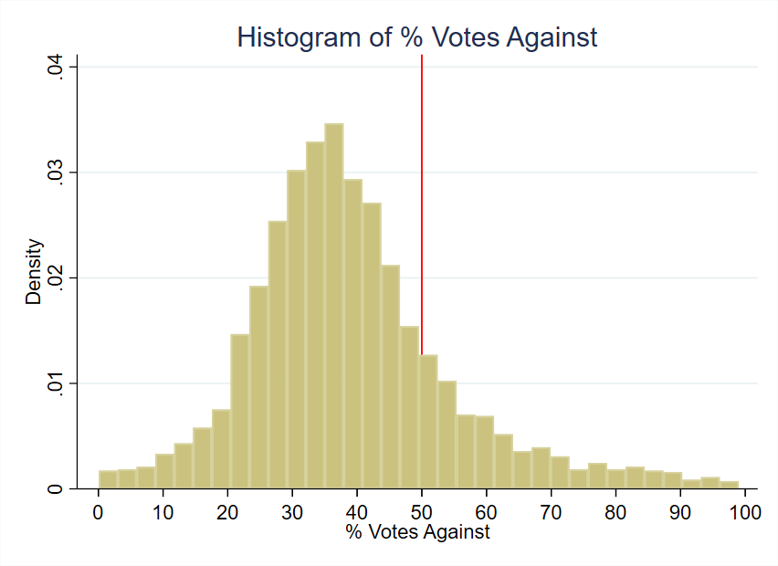
Figure 1: Histogram of Running Variable

Outcome Variable: Median House Price

Our house price data comes from a CoreLogic dataset of actual sales transaction prices in Ohio from 1995 through 2021 containing over 7 million observations. The dependent variable, Median House Price, reflects the median sale price of houses within a specific city and year. For example, for the houses sold in Delaware Township during the year 2002, the median sale price was $205,041. We take precaution to only include arm’s-length transactions, and we restrict our attention to single-family residential structures for comparability. The overall sample mean for the 10-year period from the time of votes considered in this study is $166,082 in constant 2010 dollars with a standard deviation of $372,135 which suggests the presence of outliers. Although our use of median sale price addresses outliers, one of our robustness checks drops 1% tails and re-estimates the treatment effects (Figure 7).

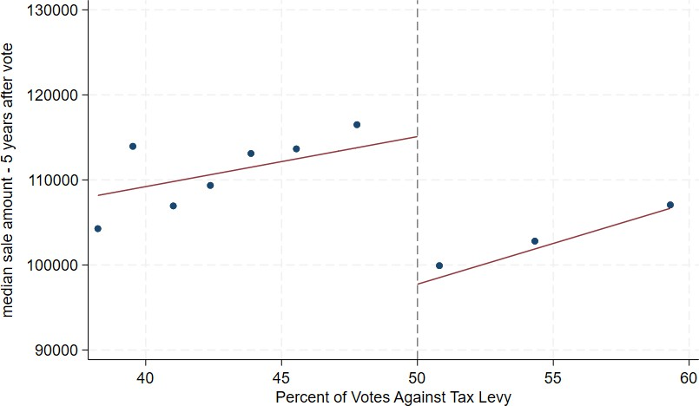

Figure 2: Median Sale Price of Houses: 5 years after vote

Figure 2 shows house prices from five years after the vote graphed alongside the percent of votes against the tax levy⁹. The points represent the mean house price for the 10 representative bins of vote shares for the average effective bandwidth around the cutoff of 50%. This visual pattern indicates a discrete jump in house prices at the 50% threshold, implying that tax levy failures lead to reduced property values.

Road Quality

Roads in Ohio last 15-20 years and deteriorate faster with poor drainage, utility cuts to the road, and snowplow damage (City of Hudson, 2020).
To understand the effect of cutting local road taxes on road quality, we fine-tune an AI vision model on satellite imagery data from Brewer et al. (2021). Following the seminal work on text-based Transformers in Natural Language Processing (NLP) by Vaswani (2017), vision transformers (ViTs) were introduced by Google Brain’s team and are part of a recent class of deep learning models that have shown to outperform classic Convolutional Neural Networks (CNNs) on image classification tasks (Dosovitskiy, 2020). Nevertheless, a more
⁹after deflating to 2010 U.S. dollars

recent class of vision models learns from ViTs and uses CNNs to achieve high accuracy on image classification tasks (Woo et al., 2023). We use one such model to classify road quality from satellite images¹⁰. Below, we outline the steps we take to assess road quality.
Satellite Images for fine-tuning. Fine-tuning a vision model involves taking a pre-
trained model and adapting it for a specific image-classification task.
In order to ensure appropriate fine-tuning and enable our vision model to accurately predict road quality, we need large-scale road-image data. We use the road-image dataset of Brewer et al. (2021) which consists of 53,677 labeled satellite images of roads in different conditions, and a classification representing quality of each road: 0 (poor), 1 (decent) and 2 (high). We divide the data into training, validation and test datasets, and use 70% of the data for training, 15% for validation and 15% for testing. For a detailed analysis of the road-image dataset, see the Appendix, Section D.
In section 4.2, we present the results from our fine-tuned model, when applied to roads in areas with close elections within the effective bandwidth.
Ohio Roads Imagery. While the fine-tuning of our vision image-classification model uses images from Brewer et al. (2021), our Ohio application uses road-centered aerial imagery collected from public imagery sources. We first use Google Earth Engine to collect images from the National Agriculture Imagery Program (NAIP), which provides repeated high-resolution aerial imagery for Ohio over much of our study period¹¹. To make sure the imagery corresponds to actual roads, we begin with TIGER road geometries that are spatially joined to county subdivisions, sample points along road line segments in each subdivision, and download image chips centered on those road points¹². Each chip covers a fixed ground window around the sampled road location, and the image manifest records the county-subdivision identifier, road name, image year, latitude, longitude, and file name.
¹⁰see the Appendix, Section D for details.
¹¹We considered using Google Earth Pro for satellite images but found these images too sparse to form a panel dataset for our study.
¹²An image chip is a small cropped tile from a larger aerial image centered on the road location used for prediction.

This procedure yields a panel-like set of road images across subdivisions and years¹³. In the empirical analysis, predicted road quality is aggregated within pre-election and post-election windows around each renewal election, election-year imagery is omitted, and each window is censored at adjacent renewal elections so the same subdivision-year is not reused across levy cycles.
Road Quality Metrics. For road quality analysis, we use two metrics derived from our fine-tuned vision model: the Road Quality Rating (RQR) and the Road Quality Score (RQS).
Road Quality Rating. Our fine-tuned vision model classifies each road image into one of three categories: 0 (poor), 1 (average), or 2 (high). This rating is based on visual cues such as pavement quality, visible cracks, patchwork, and overall surface condition, as learned by the vision model from the labeled training data. For each image, the model outputs both the predicted class and a confidence score, which reflects the model’s certainty in its prediction. These ratings provide a standardized, objective measure of road quality across locations and time periods, enabling us to compare changes in road conditions before and after tax levy referendums for both treated and control groups.
Road Quality Score. Even though our original model output is a road quality rating¹⁴, we also convert the discrete model output to a continuous Road Quality Score (RQS). This conversion uses two variables: the predicted road quality rating and the confidence score¹⁵. The formula for this conversion is as follows:
¹³We also construct a companion set of images from the Ohio Statewide Imagery Program (OSIP3) using
the same road-point sampling strategy. OSIP3 provides sharper imagery for later years, and we use it to check and supplement coverage in supporting diagnostics. However, because OSIP3 begins only after 2017, the main road-quality estimates in Table 5 report NAIP-based Road Quality Rating and Road Quality Score outcomes so that the units remain directly interpretable across post-election windows. The pooled NAIP-OSIP3 standardized estimates are used only in supporting diagnostics.
¹⁴This is a direct result of our training data from Brewer et al. (2021) which uses the discrete 0 (low), 1 (medium), 2 (high) road-quality metric.
¹⁵During the prediction process, we asked the fine-tuned vision model its confidence in the prediction i.e. the probability of the prediction being correct, a number between 0 and 1.

RQS = 1 + b 1 − wcˆ,

rˆ + wcˆ,
rˆ = 0,
rˆ ∈ {1, 2}.

(2)

where rˆ is the predicted road quality rating and cˆ is the confidence score. The parameter b determines the size of each rating bin, and w determines the weight of the confidence score which determines the sensitivity within the predicted class¹⁶. Higher confidence in a poor classification lowers the score, while higher confidence in average or high classifications raises it¹⁷. We use this RQS metric in our analysis to assess the impact of cutting local road taxes on road quality.
Next, we share a summary of means and standard deviations of the predicted road quality rating and road quality score for the treatment and control groups, before and after
the referendum.

¹⁶We set b to ⁹⁹ to give the three rating bins equal width and set w to 0.5.
¹⁷This allows the model to adjust the score based on its confidence in the prediction, providing a more nuanced measure of road quality. Under this specification, RQS ranges from 18.2 to 83.5, with larger values indicating higher road quality.
3

Table 2: Predicted Road Quality by Treatment Status and Period

 | Global |  |  |  | Effective
 | Control Treated (Renewed) (Failed) |  |  | Control (Renewed) | Treated Difference (Failed) (Treated−Control)
Panel A: Road Quality Rating (0, 1, 2)
Pre-Election (t−3 to t−1) | 1.49 | 1.55 | 1.56 |  | 1.66 | 0.10
 | (0.24) | (0.19) | (0.07) |  | (0.06) | (0.10)
Post-Election (t+3 to t+5) | 1.55 | 1.65 | 1.72 |  | 1.44 | -0.28∗∗∗
 | (0.23) | (0.18) | (0.05) |  | (0.07) | (0.07)
Panel B: Road Quality Score (RQS)
Pre-Election (t−3 to t−1) | 61.4 | 63.4 | 64.1 |  | 66.8 | 2.7
 | (8.2) | (6.9) | (2.2) |  | (2.3) | (3.6)
Post-Election (t+3 to t+5) | 63.1 | 66.6 | 69.0 |  | 59.2 | -9.8∗∗∗
 | (7.9) | (6.5) | (1.8) |  | (2.7) | (2.6)
Notes: The treated group comprises observations that failed to renew their road tax levies. The control group comprises those that renewed. The sample is the ConvNeXt V2 stacked-event NAIP road imagery sample with valid pre- and post-window imagery. Election-year imagery is omitted and windows are censored at adjacent renewal elections. Global columns are unweighted descriptive means across all observations with standard deviations in parentheses, with no bandwidth restriction. Effective columns are local-linear RD fits at the 50% vote-against cutoff, using the MSE-optimal bandwidth of h ≈ 4.4–4.7 percentage points; these are fitted values at the cutoff with standard errors in parentheses, and the treated value is the control fit plus the RD estimate. The pre-election rows are a placebo balance check and show no significant treated–control gap at the cutoff (RQR p = 0.33, RQS p = 0.45), consistent with comparability near the threshold.
Significance: *** p < 0.01, ** p < 0.05, * p < 0.1.

Table 2 reports the Road Quality Rating (RQR) in Panel A and the Road Quality Score (RQS) in Panel B. The Global columns are unadjusted means over the full sample. If we naively compare these raw averages, treated areas do not look worse than control in the

post-election window, as treated RQR is 1.65 against 1.55 for control, and treated RQS is
66.6 against 63.1. However, selection into the treatment group may not be random, and thus these comparisons may be biased due to observable and unobservable confounders. Because jurisdictions that fail and renew levies may differ systematically, these global comparisons are descriptive only and need not reflect the causal effect.
The Effective columns in Table 2 report local-linear fits at the 50% vote-share cutoff, the local comparison underlying our identification strategy. The treated and control fits show no statistically significant differences in the pre-election window. After the election, road quality in the treated group is lower than control group: RQR is 1.44 against 1.72, and RQS is 59.2 against 69.0. The Difference column compares the treated and control fits, reporting the bias-corrected RD estimate at the cutoff. Section 4.2 provides a detailed analysis of these findings.

Covariates

Covariates can be useful in RD studies, although they are not necessary for the identification of treatment effects. One use of covariates is to increase the precision of treatment effect estimates. The other is to see if cities that barely pass and fail tax levies are similar to each other like the theory of RD says they should be. Table 3 shows covariate means for both the global sample of all votes in the data set as well as the local sample within a representative effective bandwidth of the 0.50 cutoff. The effective bandwidth displayed in Table 3 is the mean bandwidth for all the housing outcome regressions. The first columns for the global sample show similar values of characteristics between cities that renew and cut road taxes and spending, but it is the two rightmost columns that are critical for the credibility of the RD design.
The data, captured at the time of the vote and as observed in Table 3, shows minimal differences within the effective bandwidth: mean population differs by only 301, and median family income varies by $436, measured in 2010 U.S. dollars. Other variables, including

poverty rates, married household percentages, educational attainment, age distribution, and racial composition, show differences of two percentage points or less, bolstering the comparability of the treatment and control groups. This similarity supports interpreting post-election outcome differences near the cutoff as effects of the renewal decision rather than pre-existing
differences¹⁸.

¹⁸We also find similar covariate means for cities that have no road tax levies, which we explain in Section 4.4.

Table 3: Variable Means & Standard Deviation by Road Tax Levy Renewal Status

Variable Global Effective
 | Full Sample | Renewed | Cut | Renewed (Control) | Cut (Treatment)
Population | 5,072 | 4,733 | 5,139 | 4,885 | 5,186
 | (7,936) | (7,291) | (8,058) | (7,036) | (8,229)
Poverty Rate | 0.11 | 0.11 | 0.11 | 0.10 | 0.11
 | (0.08) | (0.07) | (0.08) | (0.07) | (0.08)
% with Kids | 0.39 | 0.40 | 0.39 | 0.39 | 0.39
 | (0.08) | (0.08) | (0.08) | (0.07) | (0.08)
% Households with | 0.09 | 0.09 | 0.09 | 0.09 | 0.08
Children under 18
 | (0.06) | (0.05) | (0.06) | (0.06) | (0.05)
% Less than High | 0.16 | 0.18 | 0.15 | 0.18 | 0.16
School Education
 | (0.11) | (0.12) | (0.11) | (0.12) | (0.10)
% Some College | 0.25 | 0.24 | 0.25 | 0.24 | 0.25
Education
 | (0.06) | (0.06) | (0.06) | (0.07) | (0.06)
% Renters | 0.20 | 0.20 | 0.20 | 0.19 | 0.20
 | (0.11) | (0.10) | (0.11) | (0.09) | (0.11)
Unemployment Rate | 0.05 | 0.05 | 0.05 | 0.05 | 0.06
 | (0.04) | (0.03) | (0.04) | (0.03) | (0.04)
% White | 0.96 | 0.97 | 0.96 | 0.97 | 0.97
 | (0.07) | (0.07) | (0.07) | (0.07) | (0.08)
% Black | 0.02 | 0.02 | 0.02 | 0.02 | 0.02
 | (0.07) | (0.06) | (0.07) | (0.07) | (0.07)
% Married | 0.59 | 0.60 | 0.59 | 0.61 | 0.60
 | (0.09) | (0.08) | (0.09) | (0.08) | (0.09)
% Separated | 0.01 | 0.01 | 0.01 | 0.01 | 0.01
 | (0.01) | (0.01) | (0.01) | (0.01) | (0.01)
Income Heterogeneity | 0.10 | 0.09 | 0.10 | 0.09 | 0.09
Index
 | (0.08) | (0.07) | (0.08) | (0.07) | (0.06)
Median Family | 61,018 | 58,761 | 61,467 | 59,934 | 60,370
Income
 | (17,649) | (13,915) | (18,270) | (13,655) | (15,713)
% Under 5 Years Old | 0.06 | 0.06 | 0.06 | 0.06 | 0.06
 | (0.02) | (0.02) | (0.02) | (0.02) | (0.02)
% Aged 5 to 17 | 0.20 | 0.21 | 0.20 | 0.20 | 0.20
 | (0.05) | (0.04) | (0.05) | (0.04) | (0.05)
% Aged 18 to 64 | 0.60 | 0.60 | 0.60 | 0.60 | 0.60
 | (0.05) | (0.05) | (0.05) | (0.04) | (0.05)
% Racial Minority | 0.04 | 0.03 | 0.04 | 0.03 | 0.03
 | (0.07) | (0.07) | (0.07) | (0.08) | (0.07)
Number of | 3,184 | 2,656 | 528 | 653 | 269
Observations
Notes: Covariates are measured at the time of the vote. Standard deviations are in parentheses. “Global” refers to the full referendum sample with no bandwidth restriction. “Effective” refers to observations within the mean effective optimal bandwidth from the house price regressions in Table 4. Renewed jurisdictions are the control group. Jurisdictions that failed to renew their road tax levies are the treatment group.

Empirical Strategy

This section describes the research design used to estimate the local effect of narrowly failing to renew a road-maintenance levy. The estimand is an intent-to-treat effect for jurisdictions near the 50% vote-share cutoff. It is not the average effect of all tax cuts, all road-spending cuts, or all road-maintenance choices. It is the effect of losing an existing dedicated maintenance revenue stream when a renewal referendum narrowly fails.

Regression Discontinuity in Renewal Elections

Consider jurisdiction i holding a referendum in year t to renew an existing road-maintenance levy. Let v_{it} be the share of votes against renewal, and let v∗ = 0.50 be the cutoff. A levy fails when opposition exceeds the majority threshold. We define:

F_{it} = 1(v_{it} > v∗) (3)

where F_{it} indicates that the jurisdiction narrowly loses an existing road-maintenance revenue stream. The regression discontinuity design compares outcomes for jurisdictions just below and just above v∗. Around a narrow enough window, jurisdictions that barely renew and barely fail should be comparable except for the renewal outcome.
The design is well suited to renewal levies for two reasons. First, the timing of a renewal election is determined by the expiration of a previously approved levy, usually after five years. This differs from a new capital levy, where local officials can choose when to ask voters for additional funding. Second, a failed renewal has a direct fiscal interpretation: revenue from that levy stops. The resulting estimate is therefore a local intent-to-treat effect of a close electoral decision to discontinue dedicated road-maintenance funding.

Dynamic RD Specification

We estimate effects by event time relative to the election. For each outcome Y_{i,t+τ} observed
τ years after the referendum, we estimate:

Yi,t+τ = ατ + κt + FitθIT T + Pg (vit, γτ ) + Zitβτ + ϵi,t+τ (4)
τ

where θ^{IT} ^{T} is the local effect of a failed renewal τ years after the vote, κ_{t} are election-
τ
year fixed effects, P_{g}(v_{it}, γ_{τ} ) is a polynomial in the vote-share running variable, and Z_{it} includes demographic and socioeconomic covariates measured at the time of the vote. The main outcome is median house price in the jurisdiction-year. We also estimate analogous specifications for road-quality outcomes derived from road imagery.
We use the bandwidth-selection approach of Calonico et al. (2019) and estimate local polynomial regressions around the 50% cutoff. Standard errors are clustered by city to account for serial correlation within jurisdictions. The dynamic specification lets us test for pre-election discontinuities and then trace how any post-election effects evolve as deferred maintenance becomes more visible.

Results

This section shares the results of our study. We first estimate whether narrowly failing to renew road-maintenance tax cuts changes house values. We then examine road quality as mechanism evidence, describe incidence across places and housing-market segments, and summarize robustness checks that address alternative explanations.

House Prices Decline

Table 4 reports local house price estimates for the effect of narrowly failing to renew road maintenance tax cuts.

Each treatment effect estimate represents the difference in median sale price between jurisdictions just above and just below the renewal-failure cutoff. We show dynamic effects starting three years before the vote and extending to ten years after the vote. Pre-election estimates are small and statistically indistinguishable from zero. Post-election effects are also modest in the first few years, but become economically and statistically meaningful beginning in year t + 4. Estimates for years 4 through 9 after the vote are statistically significant, and the estimate for year t + 10 remains negative but is less precise. Averaging over the post-vote decade, narrowly failing to renew a road-maintenance levy is associated with a $15,350 decline in median house price, or about 9% of the average house value in the
dataset¹⁹. The delayed timing is consistent with a maintenance channel: the tax relief is
immediate, but deterioration and capitalization unfold gradually.

¹⁹The average treatment effect estimate of approximately $15,350 was divided by the mean house sale price in the dataset of $166,000 to get 9%.

Table 4: Delayed House-Price Effects after a Failed Road-Maintenance Renewal

Panel A: Years t − 3 through t + 3

Year | t−3 | t−2 | t−1 | t | t+1 | t+2 | t+3
Treatment effect | 5,307 | 166 | –273 | –4,261 | –3,908 | –11,001 | –14,733
Standard error | (7,341) | (6,943) | (7,391) | (7,955) | (8,719) | (9,405) | (7,989)
Effective bandwidth (h) | 10.30 | 10.06 | 8.76 | 7.97 | 9.78 | 9.63 | 11.93
Bias bandwidth (b) | 20.22 | 17.48 | 14.39 | 13.03 | 17.50 | 18.22 | 22.69
Effective observations | 724 | 725 | 650 | 587 | 774 | 778 | 1,003
Total observations | 2,552 | 2,631 | 2,696 | 2,784 | 2,764 | 2,699 | 2,640
Panel B: Years t + 4 through t + 10
Year | t+4 | t+5 | t+6 | t+7 | t+8 | t+9 | t+10
Treatment effect | –21,701 | –21,706 | –17,365 | –15,975 | –21,984 | –19,857 | –16,090
Standard error | (7,747) | (8,751) | (8,355) | (7,248) | (9,074) | (7,751) | (9,027)
Effective bandwidth (h) | 8.52 | 11.20 | 9.79 | 13.16 | 8.25 | 7.28 | 6.24
Bias bandwidth (b) | 16.25 | 20.16 | 17.32 | 23.42 | 15.28 | 14.09 | 16.27
Effective observations | 688 | 922 | 764 | 1,061 | 591 | 505 | 402
Total observations | 2,614 | 2,531 | 2,438 | 2,324 | 2,199 | 2,115 | 2,017
Notes: Outcome is median house price in constant 2010 U.S. dollars. Unit of observation is the city–year, so a treatment effect of –$21,701 in year t+4 means that four years after the vote, cities that fail to renew road taxes have median sale prices $21,701 lower than similar cities that renew. Covariates include the demographic and socioeconomic controls listed in Table 3.

Figure 3 summarizes the same estimates visually. Each dot is the event-time treatment effect and each bar is the 95% confidence interval. The pre-election years and the first three post-election years provide little evidence of a discontinuity in median sale prices. The decline appears only after several years, which is the timing one would expect if a failed renewal first

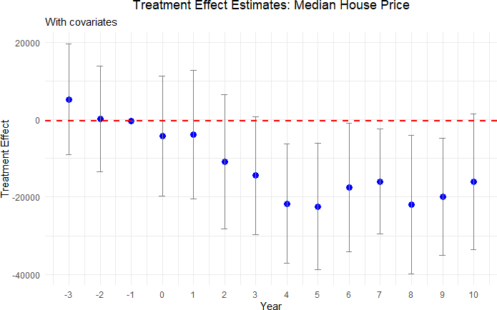

Figure 3: Delayed House-Price Losses Emerge after Year 4

reduces maintenance capacity and then affects housing markets as road conditions become more salient to buyers and sellers.

Road Quality as Mechanism Evidence

The house-price estimates are consistent with capitalization of lower road quality, but price effects alone do not necessarily establish that roads deteriorate after funding is cut. We therefore estimate analogous RD specifications using road-quality measures derived from road imagery and the vision model described in Section 2.5. The model classifies road quality on a three-point rating and we convert these ratings into a Road Quality Score (RQS) index.

Table 5: Road Quality after Failed Renewal Elections

(1) (2) (3) (4) (5) (6)

t−3 to t−1
Panel A: Road Quality Rating
t+1
to t+3
t+2
to t+4
t+3
to t+5
t+4
to t+6
t+5
to t+7

Estimate | 0.054 | 0.031 | -0.222∗∗ | -0.279∗∗∗ | -0.278∗ | -0.076
 | (0.098) | (0.080) | (0.099) | (0.070) | (0.163) | (0.232)
Eff. bandwidth (h) | 8.89 | 10.85 | 4.53 | 4.43 | 5.11 | 7.06
Bias bandwidth (b) | 15.86 | 18.55 | 8.73 | 8.34 | 7.11 | 8.96
Eff. observations | 161 | 209 | 53 | 46 | 34 | 23
Total observations | 381 | 378 | 279 | 221 | 132 | 46
Panel B: Road Quality Score
Estimate | 1.254 | 0.955 | -8.102∗∗ | -9.791∗∗∗ | -10.647∗ | -5.191
 | (3.143) | (3.088) | (3.445) | (2.621) | (6.401) | (9.094)
Eff. bandwidth (h) | 11.10 | 8.84 | 4.66 | 4.68 | 5.15 | 7.09
Bias bandwidth (b) | 18.58 | 15.31 | 8.83 | 8.73 | 7.11 | 8.99
Eff. observations | 212 | 160 | 55 | 51 | 34 | 24
Total observations | 381 | 378 | 279 | 221 | 132 | 46
Notes: Entries are bias-corrected sharp RD estimates at the 50% vote-share cutoff. Column (1) is a placebo RD using average pre-election road quality over t−3 to t−1. Columns (2)–(6) use rolling 3-year post-election windows, exclude t + 0, and control for population and the corresponding pre-election outcome. Standard errors clustered by ten-digit FIPS code are in parentheses. Statistical significance levels are indicated as follows: *** p < 0.01, ** p < 0.05, * p < 0.1.

Table 5 reports stacked-event RD estimates at the 50% vote-share cutoff. Column (1) is a placebo estimate using average pre-election road quality from t − 3 through t − 1. Columns
(2)–(6) use rolling three-year post-election windows. The placebo estimate is small and
statistically insignificant for both the discrete rating and the RQS index. In the RQS panel, the first post-election window, t + 1 to t + 3, is small and statistically insignificant. The next two windows show statistically precise declines of 8.1 and 9.8 RQS points in t + 2 to t + 4 and t + 3 to t + 5. Relative to a pre-election Road Quality Score of about 63 points, these estimates imply declines of roughly 13% and 16%, respectively²⁰. The discrete RQR panel shows the same timing, with declines of about 0.22 to 0.28 rating points across the delayed
20We compute these percentages as 100 × |βˆw |/RQ¯ Spre, where βˆw is the RD estimate for post-election window w and RQ¯ Spre is the average pre-election Road Quality Score. Using the pre-election means in Table 2, RQ¯ Spre = (63.4 +61.4)/2 = 62.4. Thus, the t +2 to t +4 estimate implies 100 × 8.102/62.4 = 13.0%, and the t + 3 to t + 5 estimate implies 100 × 9.791/62.4 = 15.7%. The t + 4 to t + 6 estimate implies 100 × 10.647/62.4 = 17.1%, but that estimate is only marginally significant at the 10% level. Because these outcomes are rolling three-year averages, the percentages describe average road-quality levels within each
post-election window rather than cumulative year-by-year deterioration.

post-election windows. The pattern supports the proposed mechanism: jurisdictions that narrowly fail to renew road-maintenance funding subsequently exhibit lower measured road quality.
We read the road-quality evidence as supporting evidence on the maintenance channel rather than as a stand-alone estimate of the full effect of levy failures on road conditions. The imagery sample is smaller than the housing sample and depends on the availability of comparable pre- and post-election road imagery, as well as the underlying fine-tuning of the vision model. For that reason, we use it to assess whether the direction and timing of physical road deterioration align with the house-price estimates, while the main outcome remains the capitalization response in the full housing panel.

Incidence and Heterogeneity

The policy implications depend not only on the average effect but also on where losses are concentrated. We therefore examine whether the capitalization response differs between urban and rural jurisdictions, larger and smaller levy failures, and lower- and higher-value segments of the housing market. These estimates speak to incidence: who is most exposed to the asset-value consequences of deferred maintenance?

Urban vs Rural neighborhoods: The capitalization of road quality may differ across places because housing supply, commuting patterns, density, and buyer salience differ between urban and rural markets. We classify urban areas using data from the U.S. Census Bureau²¹.
As shown by Figure 4, we do not find consistent price declines in rural areas after a
renewal tax levy narrowly fails. In urban areas, however, house prices decline beginning around six years after the vote. The stronger urban response may reflect denser road use,
²¹Urban areas are identified using data from U.S Census Bureau. We strictly consider urban areas with
an allocation factor of at least 0.3 in 2010 and do not consider urbanized clusters, making our classification of urban areas more restrictive.

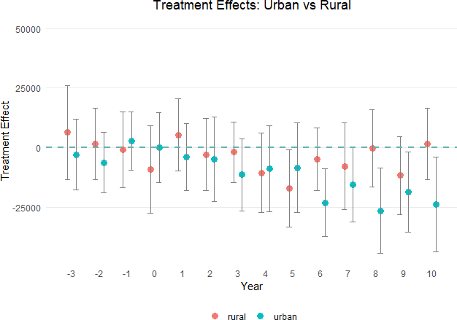

Figure 4: Urban Areas Drive the House-Price Decline

greater buyer salience, or more inelastic housing supply (Brasington, 2002). Overall, urban house prices decrease by $13,302 on average over the decade²² after a failed renewal.

Tax magnitude: We next ask whether larger failed levies produce larger losses. Splitting at the median levy size does not show a clear difference. The largest quartile of levies, however, represents a more substantial fiscal shock, with millage rates from 2.1 to 8 mills. Figure 5 presents results for this subsample.
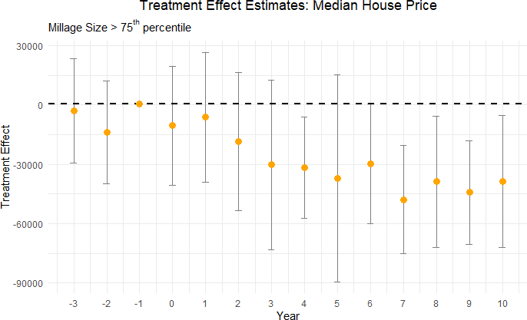

Figure 5: Larger Failed Levies Imply Larger House-Price Losses

Despite the reduction in sample size and wider confidence intervals, the decline for large failed levies is roughly $30,000, about twice the full-sample average. This pattern is consistent with an intensive-margin interpretation: larger reductions in dedicated maintenance revenue are followed by larger capitalized losses.
22This is equal to 7.6% = ^{13,302} × 100, where the denominator is average sale price of houses in urban
175,217
areas in our dataset.

RD Quantile Estimation: Finally, we estimate quantile-level treatment effects following Frandsen, Fr¨olich and Melly (2012). This analysis asks whether lower- and higher-value housing-market segments respond differently to the same local fiscal shock.
Table 6: Higher-Value Housing Segments Show Larger Capitalized Losses

Percentile | t + 4 | t + 5 | t + 6 | t + 7 | t + 8 | t + 9 | t + 10
10% | -6,433 | -22,570 | -9,602 | -12,984 | -11,217 | -6,569 | -1,326
 | (9,364) | (9,065) | (9,205) | (8,420) | (9,136) | (10,809) | (8,793)
20% | -5,400 | -15,070 | 4,014 | -14,682 | -15,040 | -3,228 | 624
 | (9,983) | (9,886) | (7,443) | (8,502) | (8,160) | (10,435) | (8,509)
70% | -21,760 | -11,171 | -38,082 | -36,685 | -21,356 | -25,605 | -18,600
 | (12,333) | (11,806) | (12,835) | (12,163) | (12,218) | (13,984) | (9,872)
80% | -28,478 | -16,379 | -38,460 | -37,470 | -28,950 | -27,800 | -18,658
 | (13,343) | (11,404) | (18,623) | (12,169) | (12,507) | (12,421) | (11,808)
90% | -51,470 | -34,604 | -38,510 | -27,039 | -29,010 | -49,093 | -36,662
 | (18,409) | (15,837) | (22,194) | (16,308) | (16,640) | (14,498) | (19,110)
Notes: The outcome is median house price in constant 2010 U.S. dollars. The unit of observation is the city-year, so a treatment effect of −$28,478 means that at the 80th percentile of house prices four years after the vote, cities that fail to renew road taxes and the associated spending have houses that sell for $28,478 less than cities that vote to renew them. Covariates include demographic and socioeconomic characteristics as described in Table 3.

Table 6 shows larger and more consistent declines in the upper part of the house-price distribution, especially beginning around year 6. Lower quantiles do not exhibit the same consistent pattern. We interpret this as evidence that higher-value housing-market segments capitalize road-quality deterioration more strongly; it should not be read as direct evidence about household wealth, since household wealth is not directly observed. Figure 6 contrasts

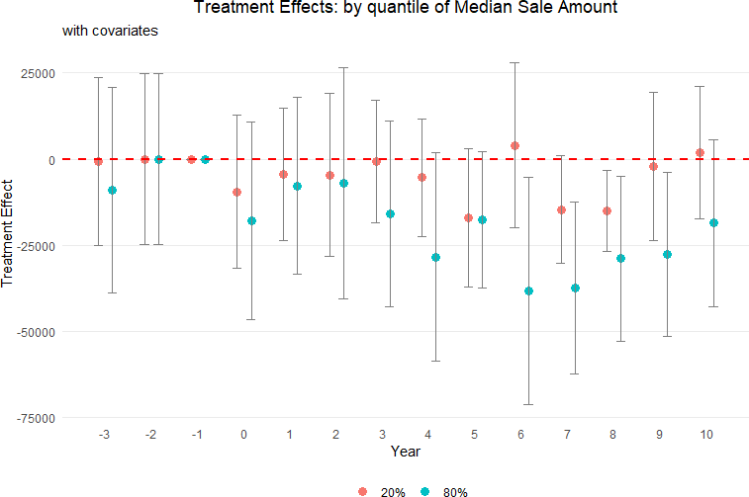

Figure 6: Higher-Value Housing Segments Show Larger Capitalized Losses

the 20th and 80th percentiles visually.

Threats to Validity and Robustness

This subsection addresses the main alternative explanations. The empirical strategy section showed no evidence of manipulation in the running variable, no statistically significant covariate discontinuities, and no pre-election house-price discontinuities. Here we focus on three additional threats to validity of our empirical design: later road levies that could contaminate the treatment path, arbitrary discontinuities at placebo cutoffs, and the possibility that a failed road renewal proxies for broader anti-tax sentiment.

Removing contaminated observations: Estimates may be biased if tax levies for additional money pass after renewal tax levy decisions. To address this concern, we exclude observations from our analysis if a tax levy for additional funding is introduced and passed within a ten-year period following a renewal tax levy vote, as these votes may contaminate the treatment effect of the renewal tax levy vote. For example, consider a scenario where a city votes to cut its renewal tax levy in the year 2000. If that city subsequently introduces and passes a tax levy for additional road spending in 2004, we exclude all votes for that city from 2005 through 2010. This exclusion ensures that the effect on house prices from the 2000 vote are captured for uncontaminated years but not for years after 2004 when the effect of additional road taxes may counteract the drop in tax money from the elections in the year 2000.

Table 7: Effect on median house prices of failing to renew a road tax levy – uncontaminated observations only

Panel A: Years t − 3 through t + 3

Year relative to vote | t−3 | t−2 | t−1 | t | t+1 | t+2 | t+3
Treatment effect | 5,295 | –369 | 1,207 | –2,482 | –3,107 | –12,236 | –15,026
Standard error | (7,255) | (7,359) | (7,776) | (8,482) | (9,270) | (10,123) | (8,746)
Effective bandwidth (h) | 10.25 | 9.70 | 8.84 | 7.48 | 9.19 | 8.20 | 10.09
Bias bandwidth (b) | 20.08 | 16.41 | 14.45 | 12.03 | 16.04 | 16.33 | 20.21
Effective observations | 719 | 682 | 630 | 510 | 680 | 604 | 763
Total observations | 2,552 | 2,574 | 2,593 | 2,640 | 2,627 | 2,536 | 2,449
Panel B: Years t + 4 through t + 10
Year relative to vote | t+4 | t+5 | t+6 | t+7 | t+8 | t+9 | t+10
Treatment effect | –21,082 | –16,827 | –17,565 | –18,179 | –20,427 | –29,970 | –23,593
Standard error | (9,145) | (11,228) | (10,128) | (9,202) | (9,829) | (9,059) | (10,838)
Effective bandwidth (h) | 6.85 | 5.64 | 8.48 | 9.34 | 7.41 | 5.51 | 6.20
Bias bandwidth (b) | 13.19 | 14.82 | 14.53 | 18.06 | 14.23 | 11.74 | 16.54
Effective observations | 473 | 367 | 573 | 609 | 442 | 303 | 322
Total observations | 2,389 | 2,274 | 2,145 | 2,016 | 1,890 | 1,787 | 1,666
Notes: Sample excludes any potentially contaminated city–year observations. Outcome is median house price in constant 2010 U.S. dollars. Each coefficient is the difference between treated and control cities in the indicated year; standard errors are heteroskedasticity-robust. All regressions control for the demographic and socioeconomic covariates listed in Table 3.

After this filtration, the post-election house-price pattern remains consistent with the baseline estimates. Standard errors increase because the sample is smaller, but the delayed negative effects remain visible.

Placebo cutoffs: In our primary analysis, the pivotal threshold for the vote share running variable is 50%, indicating whether a renewal levy passes or fails. Although we find significant treatment effects using this 50% threshold, it could be random jumps in the data rather than cutting road taxes and funding that are responsible for the significant estimates. To this end we conduct a series of placebo tests using alternative cutoffs: 30%, 40%, 60%, and 70%. Table 8 below summarizes the results from the placebo cutoffs analysis.
Table 8: Robust Treatment Effect Estimate for Placebo Cutoffs

Years after vote | 30% | 40% | 60% | 70%
t + 4 | 2,578 | 9,149 | 9,419 | -12,987
 | (8,209) | (7,284) | (11,462) | (14,365)
t + 5 | -6,381 | -29,077 | 6,383 | 41,683
 | (9,086) | (20,680) | (10,786) | (17,836)
t + 6 | 7,681 | 5,573 | -1,095 | -14,226
 | (9,616) | (8,120) | (8,612) | (15,733)
t + 7 | 1,162 | 3,982 | -12,050 | 22,261
 | (10,468) | (8,191) | (9,396) | (19,765)
t + 8 | 4,334 | 12,881 | 3,593 | 31,696
 | (9,670) | (8,625) | (10,061) | (6,902)
t + 9 | 851 | 7,381 | -6,935 | 42,790
 | (5,921) | (6,333) | (7,114) | (15,663)
t + 10 | 10,032 | -35,038 | 324 | -8,566
 | (10,599) | (35,569) | (8,220) | (17,281)

Notes: Robust treatment effect estimates at placebo cutoffs using the estimator from Calonico et al. (2017). The unit of observation is the city-year. Standard errors are reported in parentheses below each estimate.

Table 8 does not show consistently significant treatment effects for any placebo cutoff. This pattern supports the interpretation that the observed discontinuity is tied to the actual 50% renewal threshold rather than arbitrary jumps in the running variable.
Winsorization: The debate over whether to include or exclude outliers continues, with some research suggesting that trimming outliers does not improve mean squared error (Bollinger and Chandra, 2005). We now drop the 1% tails to help curtail the influence of outliers. The overall sample mean after dropping 1% tails is $150,505 in constant 2010 dollars with a standard deviation of $115,646. After performing this winsorization step, we re-estimate the treatment effect of failing to renew a road tax levy on housing outcome variables. The results from this estimation process are summarized in Figure 7 below:
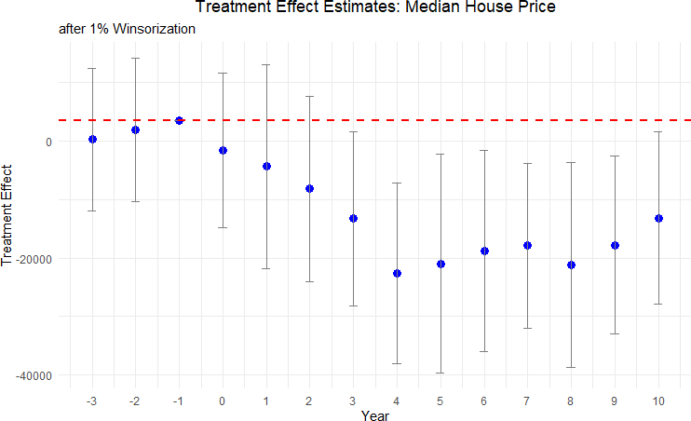

Figure 7: Effect of Cutting Road Maintenance Taxes on Median Housing Price after 1% Winsorization

The treatment effect estimates with winsorization are qualitatively and quantitatively similar to the baseline estimates.

Other Tax Levies: A potential threat to identification is that cuts in road tax levies might be correlated with cuts in other local tax levies, or may simply reveal an underlying, time-varying taste for lower taxes or smaller government. If the same electorate simultaneously rejects (or approves) levies for police, fire, recreation, or schools, our estimated road-maintenance effect could in fact be picking up broader changes in local public-service bundles that are themselves capitalized into housing prices. To address this concern, we examine whether the election results of a renewal road levy is systematically correlated with the results of other levy referenda held on the same ballot or within the same fiscal year i.e. whenever a road tax levy is cut, are there elections and subsequent tax cuts for other tax levies as well?
Table 9: Association of Road Tax Levy Referenda Results with Other Types of Levies

 | Police | Fire | Recreational | School
Estimate | 0.248 | 0.053 | 0.015 | -0.024
 | (0.153) | (0.043) | (0.317) | (0.092)
Notes: This table presents coefficients from regressions associating road tax levy referendum outcomes with outcomes for other types of levies (police, fire, recreational, school). Standard errors are reported in parentheses. All regression control for year and neighborhood fixed effects, as well as neighborhood characteristics. The school levy analysis is conducted at the county level, while all other analyses are at the county subdivisions level. Statistical significance levels are indicated as follows: *** p < 0.01, ** p < 0.05,
* p < 0.1.

Table 9 reports coefficients from separate regressions in which each column regresses the pass/fail outcome of another levy type on the pass/fail outcome of road tax levy²³, controlling for year fixed effects, jurisdiction fixed effects, and demographic covariates. For school levies we cluster to the county level as an approximation, while all other specifications are at the township/city (“county subdivision”) level. The point estimates are small and statistically indistinguishable from zero: a failed road-maintenance renewal is neither more nor less likely
²³This is represented by a dummy variable indicating a cut in road tax levies, with 1 as denoted as a cut
and 0 denoted as a renewal.

to coincide with the failure of levies earmarked for police, fire, recreation, or schools. For example, the largest coefficient, 0.248 for police levies, has a standard error of 0.153 and is not significant even at the 10 percent level. These results suggest that voters treat the road-maintenance question separately from other local tax questions, and that decisions to cut or renew road funding are not simply proxies for a general anti-tax or austerity sentiment. Consequently, our main RD estimates are unlikely to be confounded by contemporaneous changes in other public services.
A more comprehensive approach is to check for balance in other tax levies around the cutoff. We collect all 50,000 local tax levies for all municipal purposes from 1991 to 2021, including current expense levies, parks and recreation levies, and police levies. Within the effective bandwidth, jurisdictions that barely renew road taxes have a non-road tax levy on the same ballot 48.1% of the time, while jurisdictions that barely fail to renew have one 47.96% of the time. Among jurisdictions with non-road levies on the ballot, the barely renewed group experiences another tax change 12% of the time and the barely failed group does so 15% of the time. These balances suggest that the house-price results are unlikely to be driven by broad changes in the local public-service bundle.

A Benefit-Cost Assessment of Failed Renewals

Following Hendren and Sprung-Keyser (2020) and Finkelstein and Hendren (2020), we conduct a benefit-cost analysis to evaluate the overall impact of the failed renewals dedicated to road maintenance. A failed renewal delivers an immediate and visible benefit to local households: the expiring levy returns about $76 per year to the typical homeowner, a stream worth roughly $1,520 in present value. Set against this benefit is a cost that arrives only years later. As the roads deteriorate, the median home loses about $15,350 in value over the decade following the vote, as shown in Table 4.
We summarize this imbalance with the Marginal Value of Public Funds (MVPF), a benefit-cost measure that policy analysts increasingly use to express the net return to society

per dollar of public funds (Hendren and Sprung-Keyser, 2020). We define MVPF as the ratio of household’s willingness to pay (WTP) for the tax cut to the government’s net cost of providing the tax cut. WTP represents the value that households place on the tax cut, equivalent to the net present value of the tax savings and the discounted loss in house values. Net cost to the government includes both the direct long-run tax revenue loss and the fiscal externality²⁴. Using this framework, we compute an MVPF of -1.4, indicating that for every dollar of revenue loss to the government, the households incur a net loss of $1.4, after accounting for both direct costs and fiscal externalities. This negative MVPF suggests that the road maintenance tax cut leads to a net loss for households²⁵.
Why would voters choose a policy that leaves them worse off? The two sides of the ledger
differ sharply in visibility and timing. The tax savings are immediate and salient, while road depreciation is gradual and does not register in home values until about the fourth year after the vote. We interpret this as the public infrastructure analog to the fiscal illusion that Ross and Yan (2013) document for property reassessment. In Section 5, we discuss some policy levers that could potentially address this fiscal illusion.

Policy Mechanisms and Interpretation

For policymakers, the estimates point to an important trade-off between short-term tax relief and long-term capital losses. A failed renewal produces immediate tax relief for current taxpayers, but it also removes dedicated revenue for public infrastructure that deteriorates gradually. As shown in Table 4, the housing market responds to the failure of these renewals with a decline in property values about four years after the vote. This lag may reflect the time it takes for infrastructure disrepair to become salient to homeowners and potential buyers, be it through potholes, increased travel times, or reduced safety. The delayed timing
²⁴Appendix Section E provides details on the MVPF calculation.
²⁵To put this in perspective, although Hendren and Sprung-Keyser (2020) do not report a sub-category for public infrastructure and focus on government spending programs instead of tax cuts, their MVPF estimates for policies targeting adults range from 0.5 to 2.

of the house-price response, together with the road-quality evidence, is consistent with the following sequence: the levy failure reduces maintenance capacity, road conditions worsen in later years, and buyers and sellers capitalize lower public-service quality into house prices. The benefit-cost ledger tilts clearly against failed renewals as households give up far more in housing wealth than they ever save in taxes.
This interpretation matters because lower house prices are not mechanically equivalent to a social welfare loss. Current homeowners who sell after deterioration becomes visible may bear capitalized losses. Future buyers may pay lower prices but receive lower road quality. Current taxpayers receive short-run tax relief, while local governments face a smaller maintenance budget and potentially higher future repair costs if deferred maintenance compounds. The evidence therefore identifies important fiscal and asset-value consequences of failed renewals, while the policy trade-off depends on how residents and local officials weigh immediate tax relief, road quality, and future repair risk.
The urban and high-value-market results also sharpen the public-management implications. In dense markets, roads are more visible, more intensively used, and more likely to be capitalized into property values. Higher-value housing segments show larger price declines, suggesting that some owners are more exposed to the asset-value consequences of deferred maintenance. Local governments considering renewal campaigns may therefore need to communicate not only the annual household tax cost, but also the lifecycle cost of under-maintenance and the possibility that avoided taxes are capitalized into lower property values.
Three policy implications follow. First, it may help to frame renewal levies as decisions about preserving local infrastructure, rather than only as tax increases or cuts. Second, asset-condition reporting can help voters connect current maintenance funding to future road quality. Third, local governments could mitigate information frictions through targeted public disclosures, illustrating both the long-term asset-pricing impacts on housing and the fiscal inefficiency of deferring routine maintenance.

Conclusion

Local infrastructure policy often turns on routine fiscal choices rather than dramatic new investments. This paper studies one such choice: whether voters renew dedicated road-maintenance funding. Using 3,184 Ohio renewal referendums and a dynamic regression discontinuity design around close elections, we estimate the consequences of narrowly voting down an existing maintenance levy.
The results show that failed renewals have delayed but meaningful housing-market consequences. A failed levy removes about 11% of a local road-maintenance budget on average. House prices do not fall immediately, but beginning about four years after the vote, median sale prices decline by about $15,350 over the post-election decade, or roughly 9% of the average house value in the data. NAIP aerial imagery derived road-quality estimates provide suggestive mechanism evidence: post-election road-quality scores fall by up to 16% in the most precisely estimated windows. Effects are concentrated in urban markets, higher-value housing segments, and larger levy failures.
For policymakers, the central lesson is that renewal votes should be evaluated as infrastructure preservation and household-wealth decisions, not only as tax decisions. A household may save a relatively small annual tax payment when a renewal fails, but the community may later face lower road quality and capitalized asset-value losses. Systematic asset-condition reporting and transparent lifecycle communication can help equip voters to internalize these compounding fiscal costs before deferred maintenance manifests as visible infrastructure decay.
The estimates are local to jurisdictions near the 50% renewal threshold and should not be interpreted as the average effect of every road tax cut. They nevertheless identify a common and policy-relevant margin: close elections that decide whether existing local maintenance funding continues. As state and local governments confront aging infrastructure, the evidence suggests that maintaining these existing assets can be as important for local welfare and housing markets as building new infrastructure.

Data Availability Statement

Replication code and documentation for the analyses will be made available in a public repository. Election data, local financial records, NAIP imagery, and other public inputs used in the analysis are available from the sources cited in the paper. CoreLogic housing transaction data are proprietary and cannot be redistributed. Researchers seeking access must obtain them directly from CoreLogic under a separate data-use agreement. Replication files that use restricted CoreLogic data will include code to reproduce the analysis for users with authorized access.

References
American Society of Civil Engineers. 2025. “2025 Infrastructure Report Card: Roads.”
Asher, Sam, and Paul Novosad. 2020. “Rural roads and local economic development.”
American Economic Review, 110(3): 797–823.
Asher, Sam, Teevrat Garg, and Paul Novosad. 2020. “The ecological impact of transportation infrastructure.” The Economic Journal, 130(629): 1173–1199.
Beenstock, Michael, Daniel Feldman, and Daniel Felsenstein. 2016. “Hedonic pricing when housing is endogenous: The value of access to the trans-Israel highway.” Journal of Regional Science, 56(1): 134–155.
Biasi, Barbara, Julien Lafortune, and David Sch¨onholzer. 2025. “What works and for whom? Effectiveness and efficiency of school capital investments across the U.S.” The Quarterly Journal of Economics, qjaf013.
Boesen, Ulrik. 2021. “How are your state’s roads funded?” Accessed: 2025-01-23.
Bollinger, Christopher R, and Amitabh Chandra. 2005. “Iatrogenic specification error: A cautionary tale of cleaning data.” Journal of Labor Economics, 23(2): 235–257.
Brasington, David M. 2002. “Edge versus center: Finding common ground in the capitalization debate.” Journal of Urban Economics, 52(3): 524–541.
Brasington, David M. 2017. “School spending and new construction.” Regional Science and Urban Economics, 63: 76–84.
Brewer, Ethan, Jason Lin, Peter Kemper, John Hennin, and Dan Runfola. 2021. “Predicting road quality using high resolution satellite imagery: A transfer learning ap-proach.” Plos one, 16(7): e0253370.
Calonico, Sebastian, Matias D Cattaneo, Max H Farrell, and Roc´ıo Titiunik. 2017. “rdrobust: Software for regression-discontinuity designs.” The Stata Journal, 17(2): 372–

404.
Calonico, Sebastian, Matias D Cattaneo, Max H Farrell, and Roc´ıo Titiunik. 2019. “Regression discontinuity designs using covariates.” Review of Economics and Statistics, 101(3): 442–451.
Cattaneo, Matias D, Michael Jansson, and Xinwei Ma. 2020. “Simple local polynomial density estimators.” Journal of the American Statistical Association, 115(531): 1449–1455.
Cellini, Stephanie R, Fernando Ferreira, and Jesse Rothstein. 2010. “The value of school facility investments: Evidence from a dynamic regression discontinuity design.” The Quarterly Journal of Economics, 125(1): 215–261.
City of Hudson. 2020. “Asphalt Road Resurfacing Frequently Asked Questions (FAQ’s).” Accessed: 2025-05-19.
Currier, Lauren, Edward L Glaeser, and Gabriel E Kreindler. 2023. “Infrastructure inequality: Who pays the cost of road roughness?” National Bureau of Economic Research Working Paper w31981.
Dosovitskiy, Alexey. 2020. “An image is worth 16x16 words: Transformers for image recognition at scale.” arXiv preprint arXiv:2010.11929.
Dub´e, Jean, Di`ego Legros, and Nicolas Devaux. 2018. “From bus to tramway: Is there an economic impact of substituting a rapid mass transit system? An empirical investigation accounting for anticipation effect.” Transportation Research Part A: Policy and Practice, 110: 73–87.
Edel, Matthew, and Elliott Sclar. 1974. “Taxes, spending, and property values: Supply adjustment in a Tiebout-Oates model.” Journal of Political Economy, 82(5): 941–954.
Federal Highway Administration. 2022. “Highway Statistics 2022.”
Finkelstein, Amy, and Nathaniel Hendren. 2020. “Welfare analysis meets causal infer-ence.” Journal of Economic Perspectives, 34(4): 146–167.
Frandsen, Brigham R., Markus Fr¨olich, and Blaise Melly. 2012. “Quantile treatment effects in the regression discontinuity design.” Journal of Econometrics, 168(2): 382–395.
Fretz, Stephan, Rapha¨el Parchet, and Fr´ed´eric Robert-Nicoud. 2022. “Highways, market access and spatial sorting.” The Economic Journal, 132(643): 1011–1036.
Gertler, Paul J, Marco Gonzalez-Navarro, Tadeja Graˇcner, and Alexander D Rothenberg. 2024. “Road maintenance and local economic development: Evidence from Indonesia’s highways.” Journal withheld for peer review, 143: 103687.
Ghani, Ejaz, Arti Grover Goswami, and William R Kerr. 2016. “Highway to success: The impact of the Golden Quadrilateral project for the location and performance of Indian manufacturing.” The Economic Journal, 126(591): 317–357.
Gibbons, Stephen, Teemu Lyytik¨ainen, Henry G Overman, and Rosa Sanchis-Guarner. 2019. “New road infrastructure: The effects on firms.” Journal withheld for

peer review, 110: 35–50.
Gonz´alez, Felipe, Josepa Miquel-Florensa, Mounu Prem, and St´ephane Straub. 2025. “The dark side of infrastructure: Roads, repression and land in authoritarian Paraguay.” The Economic Journal, 135(666): 653–669.
Gonzalez-Navarro, Marco, and Climent Quintana-Domeque. 2016. “Paving streets for the poor: Experimental analysis of infrastructure effects.” Review of Economics and Statistics, 98(2): 254–267.
Grosz, Michel, and Ross Milton. 2025. “Relaxing electoral constraints in local education funding.” Journal of Policy Analysis and Management, 44(4): 1394–1416.
Hendren, Nathaniel, and Ben Sprung-Keyser. 2020. “A unified welfare analysis of government policies.” The Quarterly journal of economics, 135(3): 1209–1318.
Hilber, Christian AL. 2011. “The economic implications of house price capitalization: A survey of an emerging literature.” Spatial Economics Research Centre Discussion Paper,
, (91).
Hoogendoorn, Sander, Jochem van Gemeren, Paul Verstraten, and Kees Folmer. 2019. “House prices and accessibility: Evidence from a quasi-experiment in transport infrastructure.” Journal of Economic Geography, 19(1): 57–87.
Huang, Yiping. 2016. “Understanding China’s belt & road initiative: motivation, framework and assessment.” China Economic Review, 40: 314–321.
Levkovich, Oleg, Jan Rouwendal, and Rolf Van Marwijk. 2016. “The effects of highway development on housing prices.” Transportation, 43(2): 379–405.
Moulton, Jeremy G, Bennie D Waller, and Scott A Wentland. 2018. “Who benefits from targeted property tax relief? Evidence from Virginia elections.” Journal of Policy Analysis and Management, 37(2): 240–264.
Oates, Wallace E. 1969. “The effects of property taxes and local public spending on property values: An empirical study of tax capitalization and the Tiebout hypothesis.” Journal of Political Economy, 77(6): 957–971.
Oates, Wallace E. 1972. Fiscal federalism. New York:Harcourt Brace Jovanovich.
Ohio Department of Taxation. 2020. “Real property tax – General.” Accessed: 2025-01-30.
Ohio Department of Transportation. 2023. “2023 Annual Report.” Accessed: 2024-01-23.
Peter G. Peterson Foundation. 2024. “The Highway Trust Fund explained.” Accessed: 2025-01-23.
Public Service Department of Beavercreek Township. 2025. “Road funding & maintenance in Beavercreek Township, Ohio.” Personal communication, Personal communication, January 21, 2025.
Ross, Justin M, and Wenli Yan. 2013. “Fiscal illusion from property reassessment? An

empirical test of the residual view.” National Tax Journal, 66(1): 7–32.
Theisen, Theis, and Anne Wenche Emblem. 2021. “The road to higher prices: Will improved road standards lead to higher housing prices?” The Journal of Real Estate Finance and Economics, 62: 258–282.
Urban Institute. 2021. “Highway and road expenditures.”
U.S. Department of Transportation. 2022. “The bipartisan infrastructure law will deliver for Ohio.” Accessed: 2025-01-23.
Vaswani, A. 2017. “Attention is all you need.” Advances in Neural Information Processing Systems.
Wong, Ho Lun, Yu Wang, Renfu Luo, Linxiu Zhang, and Scott Rozelle. 2017. “Local governance and the quality of local infrastructure: Evidence from village road projects in rural China.” Journal of Public Economics, 152: 119–132.
Woo, Sanghyun, Shoubhik Debnath, Ronghang Hu, Xinlei Chen, Zhuang Liu, In So Kweon, and Saining Xie. 2023. “Convnext v2: Co-designing and scaling convnets with masked autoencoders.” 16133–16142.

Appendix
- Road Tax Renewal Elections in Ohio
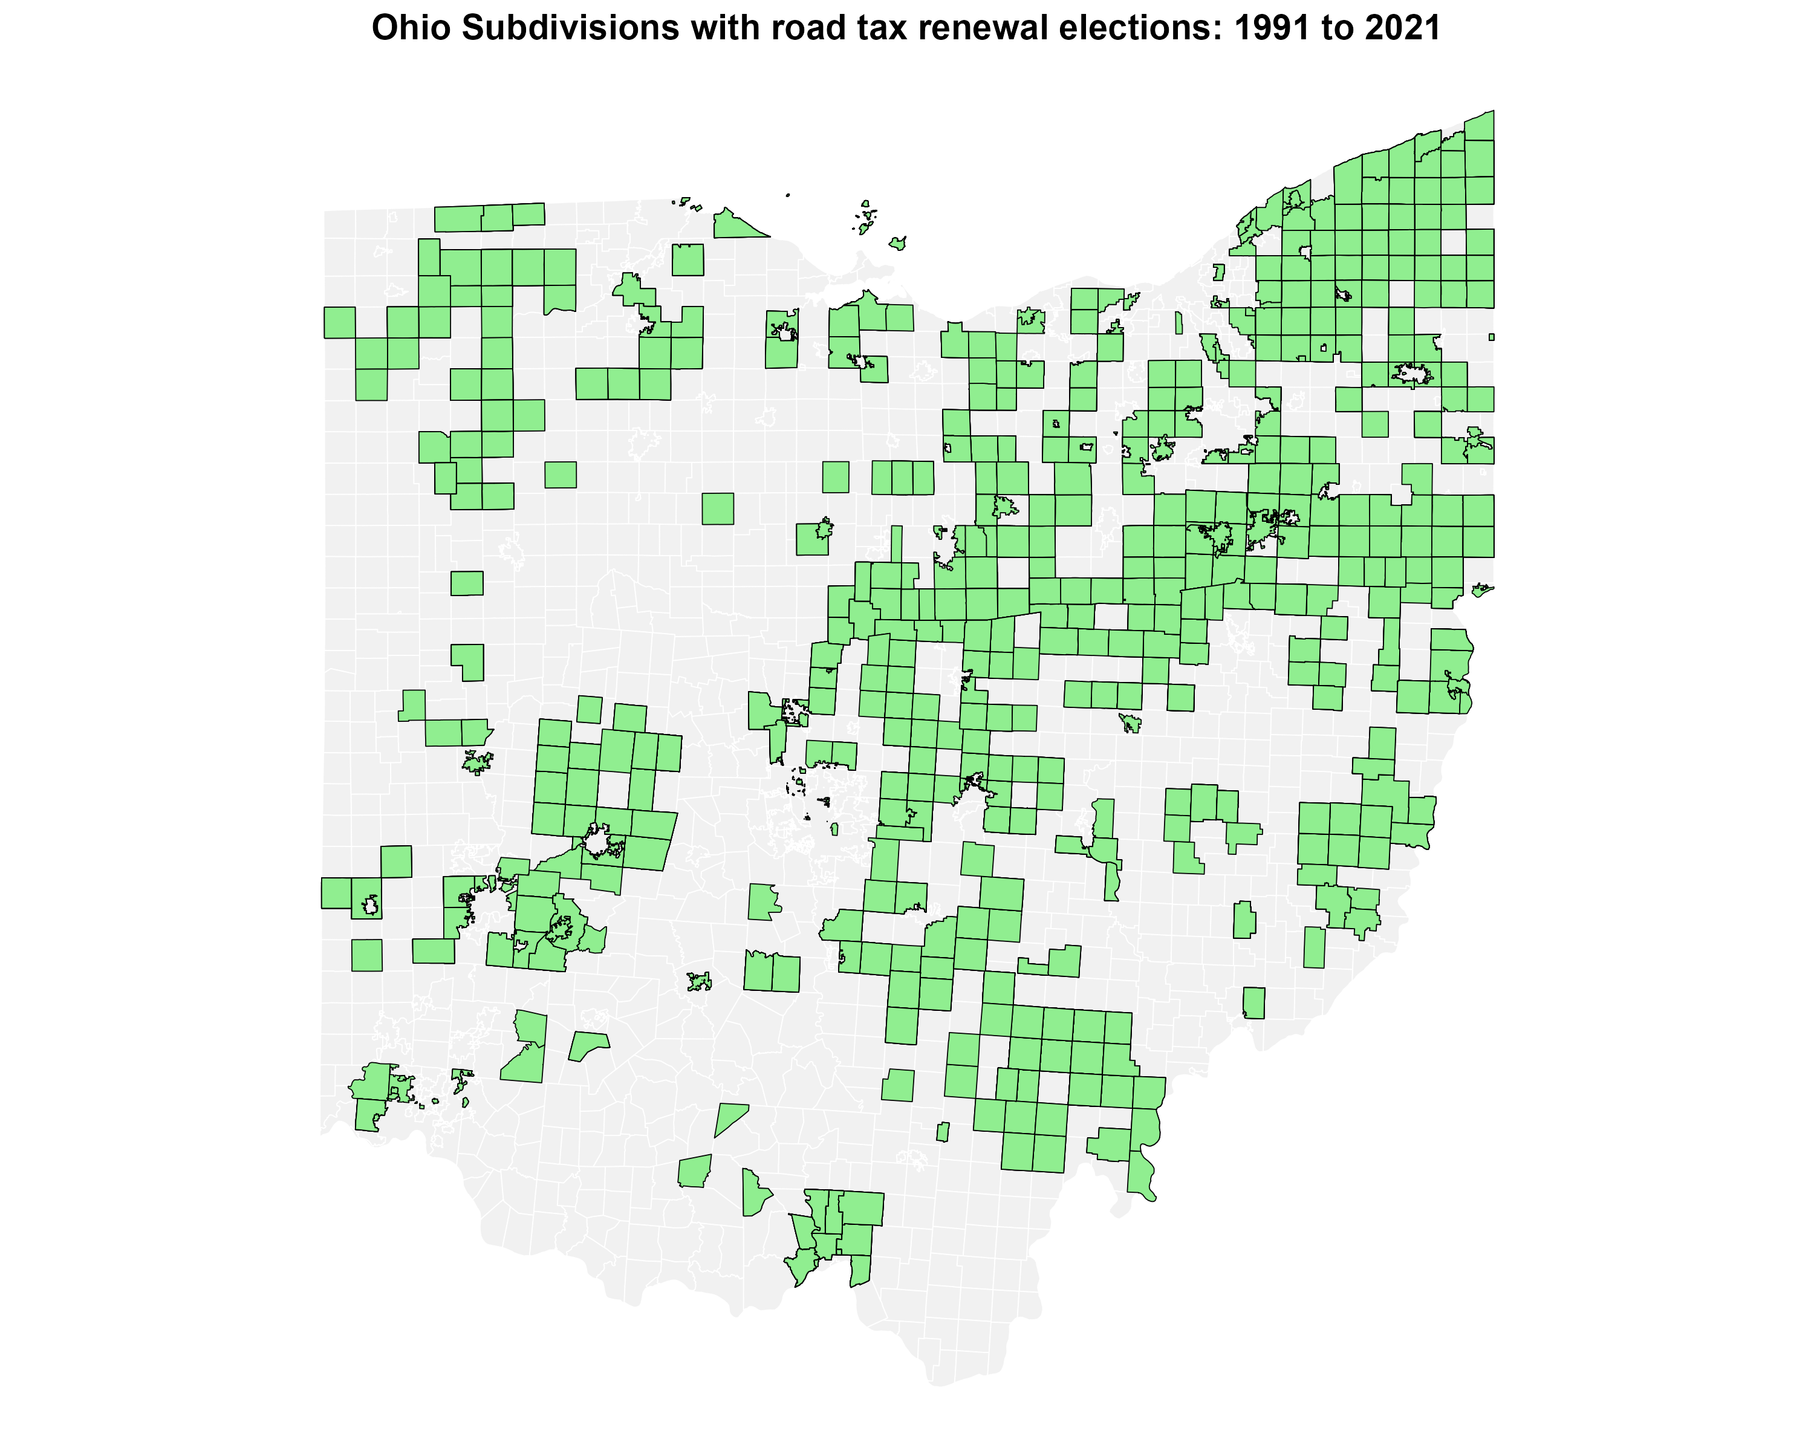
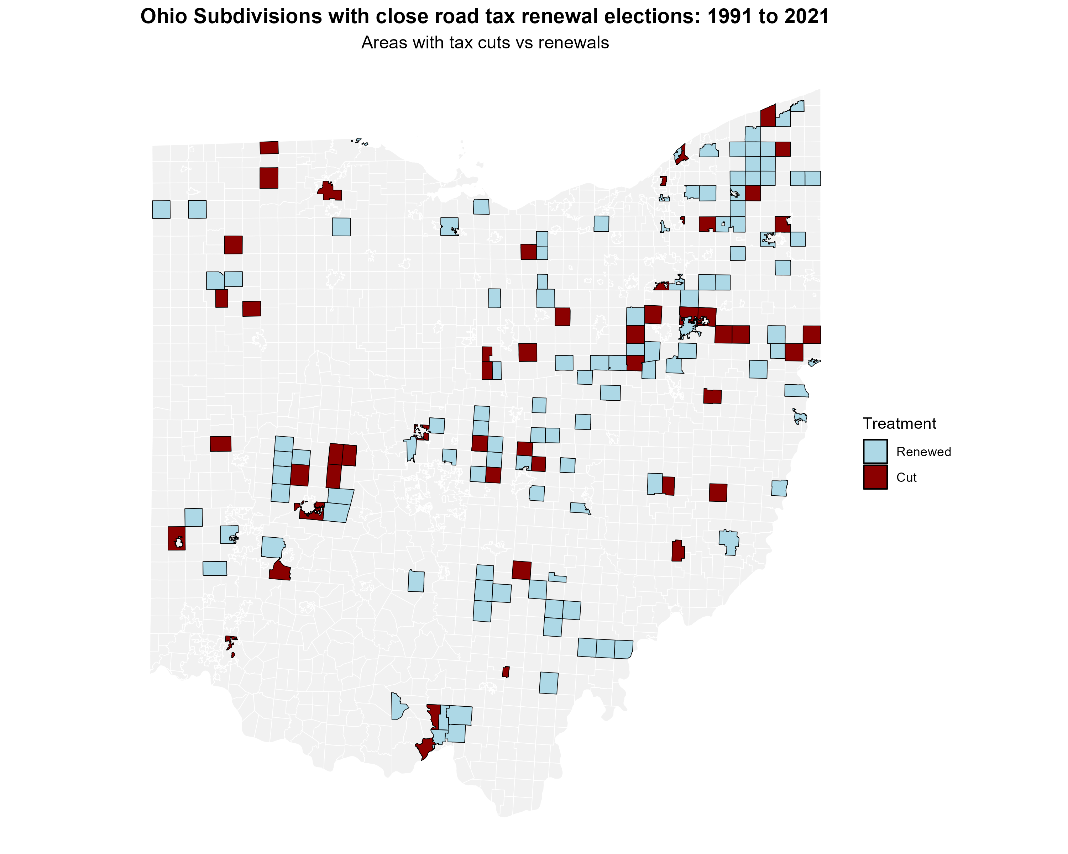

Figure 8: All Road Tax Renewal Elections in Ohio (1991-2021)
Figure 9: Close Road Tax Renewal Elections in Ohio (1991-2021)

Figure 8 displays the distribution of county subdivisions in Ohio that held at least one road tax renewal election between 1991 and 2021. The map reveals that although elections are relatively dispersed, they are more common in metropolitan areas such as Cleveland, Columbus, Cincinnati, Toledo etc. For jurisdictions that held multiple elections during this period, Figure 9 focuses on the subset of elections that were decided by narrow margins, specifically those closest to the 50% approval threshold that forms the basis of our regression discontinuity analysis. These close elections provide the quasi-experimental variation we exploit to identify the causal effects of road tax levy decisions on housing prices, and we do not observe any spatial clustering of the appearance of these close elections on the ballot, as well as the results of these close elections. The geographic distribution of close elections largely mirrors that of all elections, suggesting that narrow electoral outcomes are not systematically concentrated in particular types of communities, which supports the validity of our identification strategy.

Additional Tables

Full set of Treatment Effects
Tables below present the full set of treatment effects for the results presented in our heterogeneity analysis and robustness checks. Table 10 presents the treatment effects after applying 1% winsorization to the data, ensuring robustness against outliers. Table 11 breaks down the treatment effects by urban and rural categories, highlighting the differential impacts on housing prices based on the urbanization level.

Table 10: Full set of estimates – Median Housing Price (after 1% Winsorization)

Year  to vote | relative | Estimate | Std. error | p-value | Confidence interval
t − 3 |  | 258 | 6,217 | 0.967 | [−11,927, 12,443]
t − 2 |  | 1,870 | 6,257 | 0.765 | [−10,393, 14,134]
t − 1 |  | 3,489 | 7,202 | 0.628
t |  | −1,626 | 6,730 | 0.809 | [−14,818, 11,566]
t + 1 |  | −4,312 | 8,906 | 0.628 | [−21,767, 13,143]
t + 2 |  | −8,190 | 8,099 | 0.312 | [−24,063, 7,683]
t + 3 |  | −13,275 | 7,588 | 0.080 | [−28,146, 1,597]
t + 4 |  | −22,582 | 7,904 | 0.004 | [−38,074, −7,090]
t + 5 |  | −20,952 | 9,554 | 0.028 | [−39,678, −2,225]
t + 6 |  | −18,793 | 8,789 | 0.033 | [−36,020, −1,566]
t + 7 |  | −17,918 | 7,180 | 0.013 | [−31,990, −3,845]
t + 8 |  | −21,146 | 8,921 | 0.018 | [−38,631, −3,660]
t + 9 |  | −17,789 | 7,770 | 0.022 | [−33,018, −2,561]
t + 10 |  | −13,147 | 7,526 | 0.081 | [−27,898, 1,604]
Notes: Supplements Figure 7 in main text. This table reports the treatment-effect estimates of cutting road tax levies (relative to renewing them) from three years before to ten years after the vote. Columns show the year relative to the referendum vote, estimated treatment effect, standard error, p-value, and 95% confidence interval. Data are winsorized at the 1% level. All regressions include the covariates listed in Table 3. The outcome is the median house price in constant 2010 U.S. dollars (city-year observations). A coefficient of −22,582 at t + 4 means that, four years after the vote, cities that cut their levies had median house prices $22,582 lower than those that renewed. Standard errors are robust and clustered at the county subdivision level.

Table 11: Treatment Effects on Housing Prices by Urban vs. Rural Categories
Panel A: Urban
Year | Estimate | Std. Error | p-value | Conf. Interval
t − 3 | -2,636 | 8,066 | 0.744 | [-18,446, 13,173]
t − 2 | -9,607 | 7,310 | 0.189 | [-23,935, 4,722]
t − 1 | 1,045 | 6,496 | 0.872
t | 458 | 7,873 | 0.954 | [-14,973, 15,889]
t + 1 | -5,087 | 7,617 | 0.504 | [-20,016, 9,843]
t + 2 | -3,675 | 9,077 | 0.686 | [-21,465, 14,115]
t + 3 | -11,657 | 7,667 | 0.128 | [-26,684, 3,370]
t + 4 | -8,846 | 9,162 | 0.334 | [-26,804, 9,112]
t + 5 | -8,967 | 9,311 | 0.336 | [-27,217, 9,284]
t + 6 | -24,476 | 7,127 | 0.001 | [-38,446, -10,507]
t + 7 | -14,457 | 7,869 | 0.066 | [-29,880, 966]
t + 8 | -26,174 | 8,921 | 0.003 | [-43,659, -8,688]
t + 9 | -19,469 | 8,221 | 0.018 | [-35,582, -3,357]
t + 10 | -23,969 | 10,364 | 0.021 | [-44,284, -3,655]
Panel B: Rural
Year | Estimate | Std. Error | p-value | Conf. Interval
t − 3 | 6,384 | 9,962 | 0.522 | [-13,142, 25,910]
t − 2 | 1,609 | 7,758 | 0.836 | [-13,597, 16,814]
t − 1 | -835 | 8,354 | 0.920
t | -8,727 | 9,351 | 0.351 | [-27,056, 9,601]
t + 1 | 5,731 | 7,458 | 0.442 | [-8,886, 20,349]
t + 2 | -2,970 | 7,107 | 0.676 | [-16,899, 10,960]
t + 3 | -1,866 | 6,538 | 0.775 | [-14,681, 10,949]
t + 4 | -10,505 | 8,641 | 0.224 | [-27,441, 6,431]
t + 5 | -16,897 | 7,564 | 0.026 | [-31,722, -2,072]
t + 6 | -4,561 | 6,551 | 0.486 | [-17,402, 8,280]
t + 7 | -7,632 | 8,936 | 0.393 | [-25,146, 9,882]
t + 8 | -469 | 8,063 | 0.954 | [-16,273, 15,335]
t + 9 | -11,492 | 8,383 | 0.170 | [-27,923, 4,940]
t + 10 | 1,851 | 7,790 | 0.812 | [-13,417, 17,119]
Notes: Supplements Figure 4 in text. Each panel reports separate regressions of median house price on a referendum “cut vs. maintain” indicator, broken down by Urban and Rural classifications. Columns show the year relative to the referendum vote, estimated treatment effect, standard error, p-value, and 95% confidence interval. A negative estimate indicates lower house prices in areas that cut their road taxes relative to areas that maintain them. Standard errors are robust and clustered at the county subdivision level.

Table 12: Treatment Effect on Housing Prices for Top-Quartile Tax Cuts

Year relative to vote | Estimate | Std. error | p-value | Confidence interval
t − 3 | -2,850 | 13,435 | 0.832 | [−29,183, 23,482]
t − 2 | -13,984 | 13,290 | 0.293 | [−40,032, 12,064]
t − 1 | 447 | 12,148 | 0.971
t | -10,456 | 15,381 | 0.497 | [−40,603, 19,692]
t + 1 | -6,199 | 16,738 | 0.711 | [−39,006, 26,608]
t + 2 | -18,657 | 17,844 | 0.296 | [−53,631, 16,317]
t + 3 | -30,307 | 21,968 | 0.168 | [−73,365, 12,751]
t + 4 | -31,679 | 13,072 | 0.015 | [−57,300, −6,058]
t + 5 | -37,063 | 26,790 | 0.167 | [−89,571, 15,446]
t + 6 | -29,830 | 15,478 | 0.054 | [−60,167, 508]
t + 7 | -47,933 | 13,968 | 0.001 | [−75,310, −20,557]
t + 8 | -38,800 | 16,894 | 0.022 | [−71,913, −5,687]
t + 9 | -44,279 | 13,410 | 0.001 | [−70,563, −17,995]
t + 10 | -38,659 | 17,087 | 0.024 | [−72,150, −5,168]
Notes: Supplements Figure 5 in the text. Estimates compare cities that failed to renew a large (top-quartile) road maintenance tax levy with similar cities that renewed. Columns show the year relative to the referendum vote, estimated treatment effect, standard error, p-value, and 95% confidence interval. The outcome is median house price in constant 2010 U.S. dollars; the unit of observation is the city–year. Covariates from Table 3 are included in every regression. A treatment effect of −$31,679 in year t + 4 means that four years after the vote, treated cities’ median sale prices are $31,679 lower than those of renewing cities. Standard errors are robust and clustered at the county subdivision level.

Additional Robustness Tests
A key RD assumption is that observations just above and below the threshold are comparable in all aspects except for treatment status. Table 13 presents balance tests across community characteristics at the voting threshold. As shown, demographic and socioeconomic vari-ables—including population size, poverty rates, educational attainment, employment status, and racial composition—exhibit no statistically significant discontinuities at the cutoff. The absence of any discontinuity suggests that our estimated effects on housing prices represent the impact of failing to renew road tax levies rather than pre-existing community differences. This balance verification via a formal RD test, using covariates as the outcome variable, strengthens our conclusion that the observed housing price effects stem from decisions regarding road tax levies, not from underlying differences in community characteristics.

Covariate Discontinuity Table

Table 13: Covariate Discontinuity Test Results

Variable | Estimate | Std. error | p-value | Confidence interval
Population | −388 | 1,094 | 0.722 | [−2,532, 1,755]
Poverty Rate | 0.017 | 0.014 | 0.234 | [−0.011, 0.045]
% with Kids | −0.007 | 0.012 | 0.539 | [−0.030, 0.015]
% Households with Chil- | 0.0001 | 0.007 | 0.981 | [−0.014, 0.014]
dren < 18
% Less than High School | −0.004 | 0.020 | 0.834 | [−0.043, 0.035]
Education
% Some College Education | −0.012 | 0.011 | 0.274 | [−0.034, 0.009]
% Renters | −0.005 | 0.015 | 0.754 | [−0.035, 0.025]
Unemployment Rate | −0.002 | 0.006 | 0.733 | [−0.013, 0.009]
% White | −0.007 | 0.011 | 0.499 | [−0.028, 0.014]
% Black | −0.004 | 0.009 | 0.685 | [−0.021, 0.014]
% Married | −0.013 | 0.015 | 0.374 | [−0.042, 0.016]
% Separated | 0.001 | 0.002 | 0.485 | [−0.002, 0.004]
Income Heterogeneity Index | 0.007 | 0.013 | 0.566 | [−0.018, 0.033]
Median Family Income ($) | −3,147 | 2,963 | 0.288 | [−8,953, 2,660]
% Under 5 Years Old | −0.006 | 0.004 | 0.126 | [−0.013, 0.002]
% Aged 5 to 17 | −0.007 | 0.007 | 0.284 | [−0.021, 0.006]
% Aged 18 to 64 | 0.004 | 0.008 | 0.611 | [−0.012, 0.021]
% Racial Minority | 0.007 | 0.011 | 0.499 | [−0.014, 0.028]
Notes: Each row reports the estimated discontinuity at the levy-approval cutoff for the specified covariate, using robust local-linear RD with the mean effective bandwidth. Confidence intervals are 95%.

Covariate Discontinuity Plots

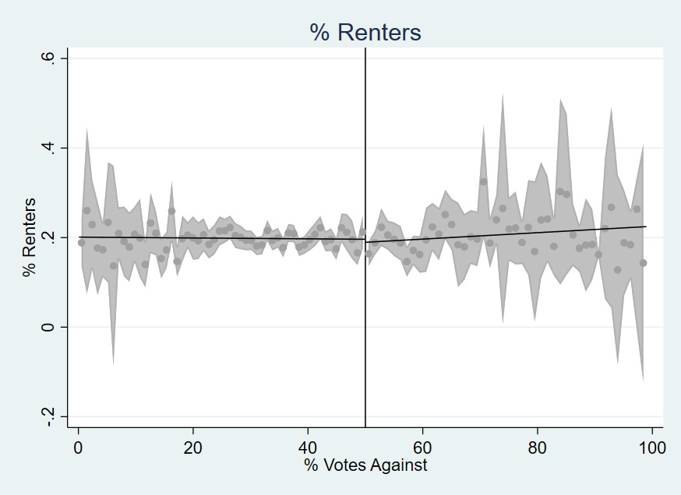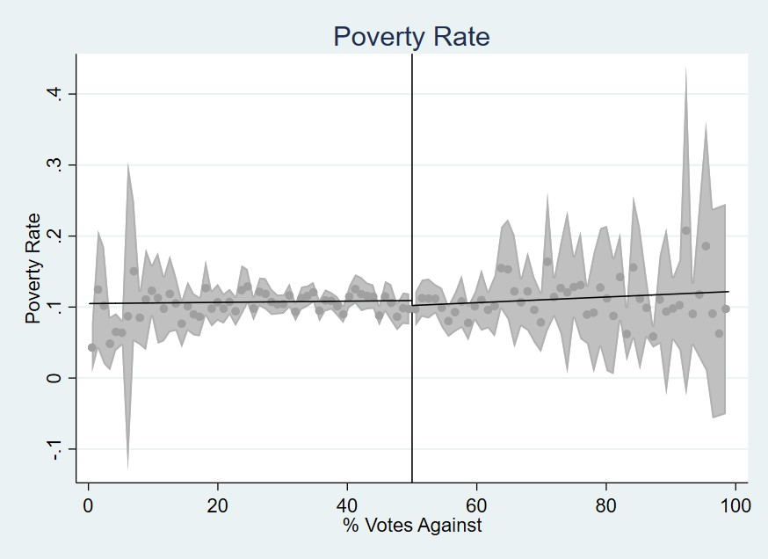
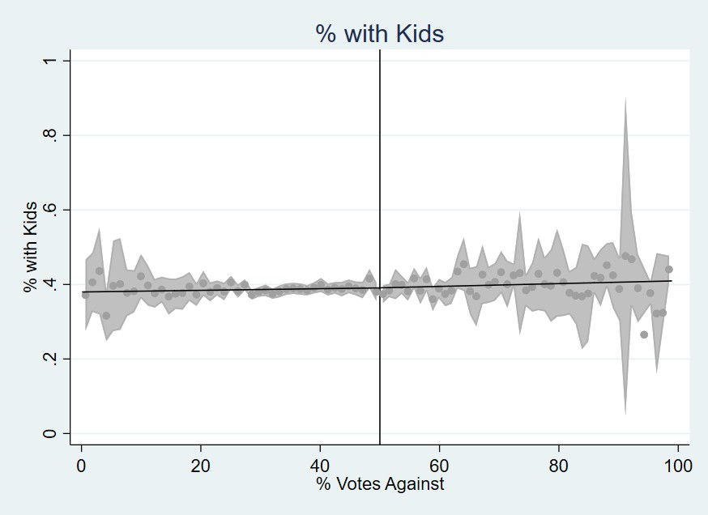
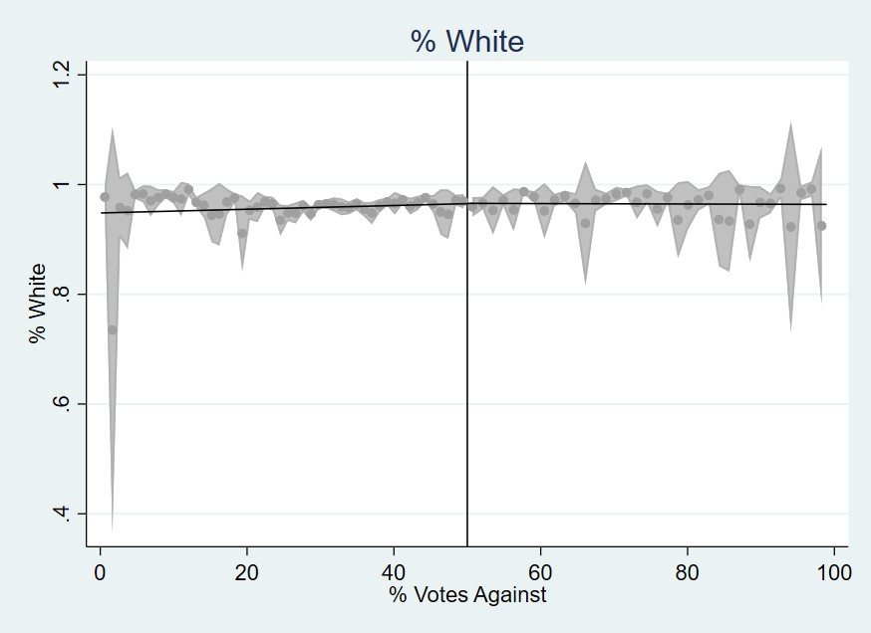
% Renters Poverty Rate
% With Kids % White
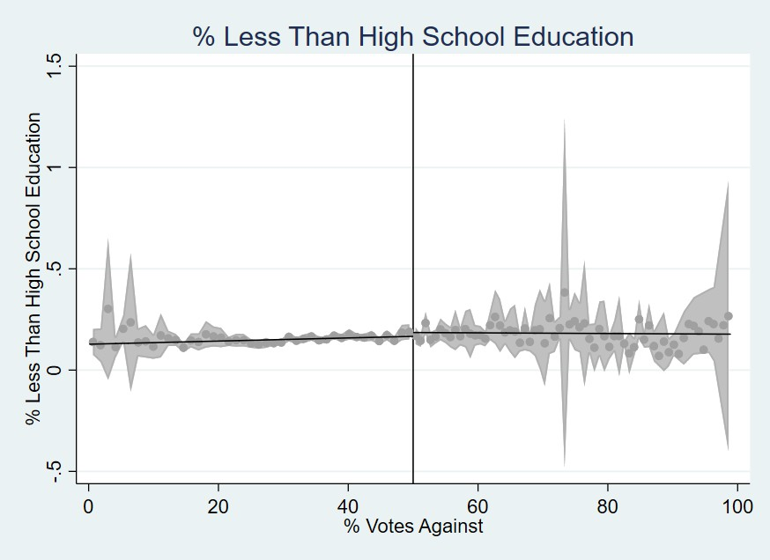
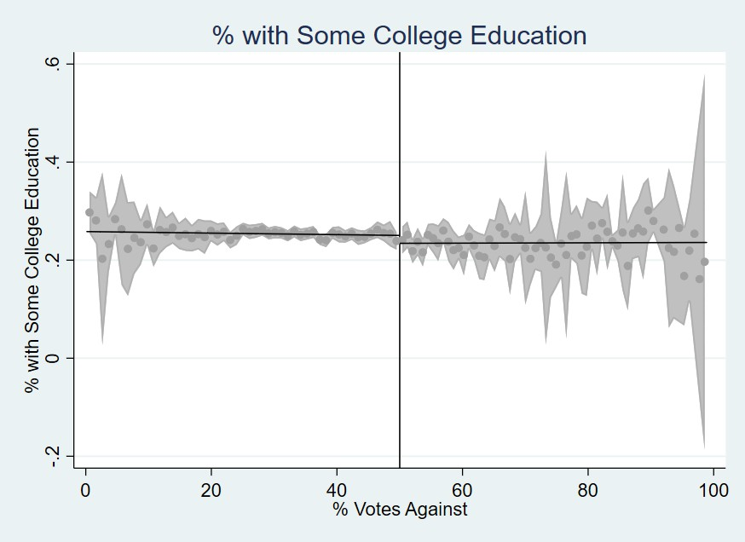
% with Less than High School edu-
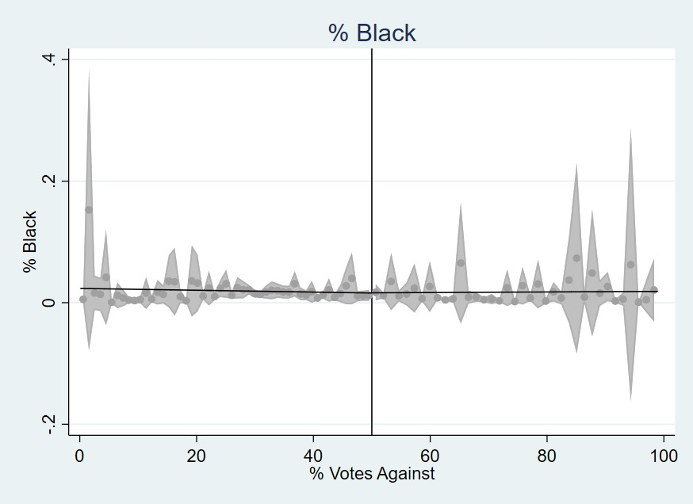
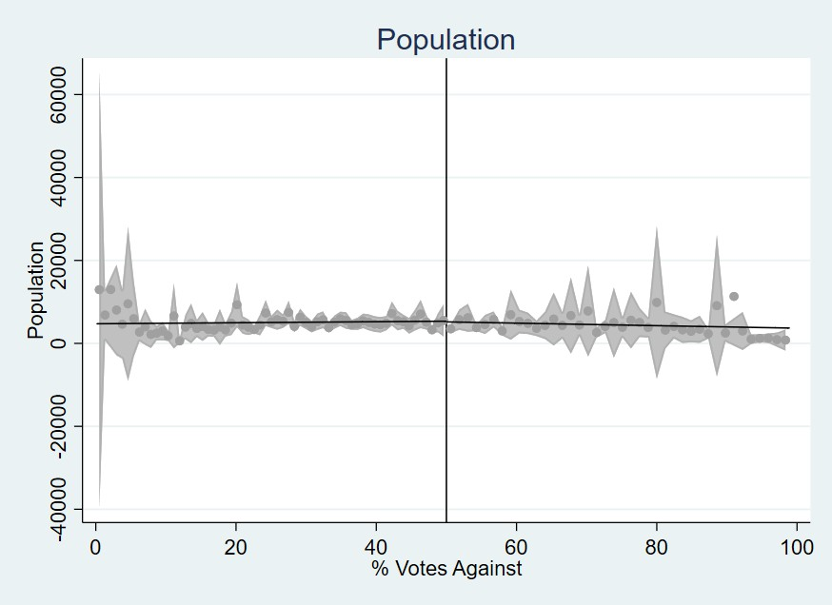
cation % Attended Some College
% Black Population

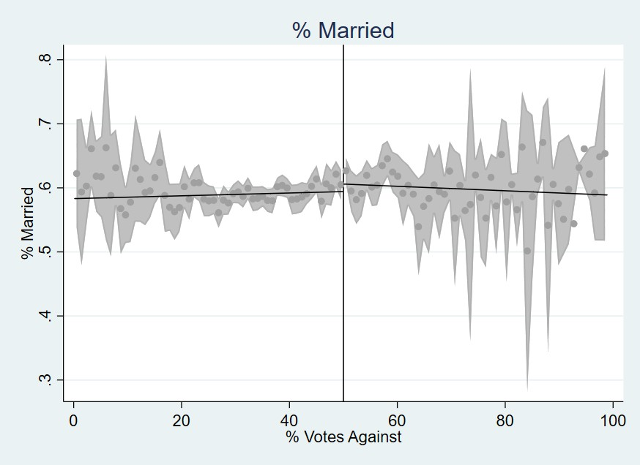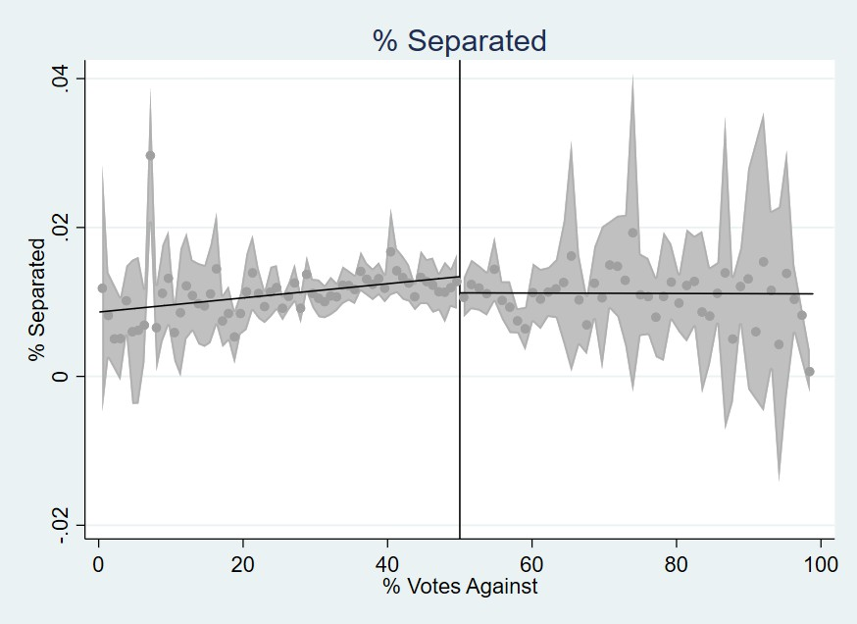
% Married % Separated
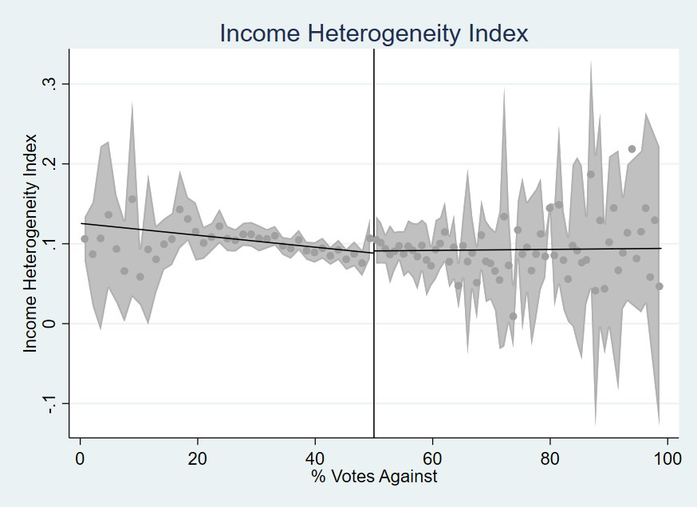
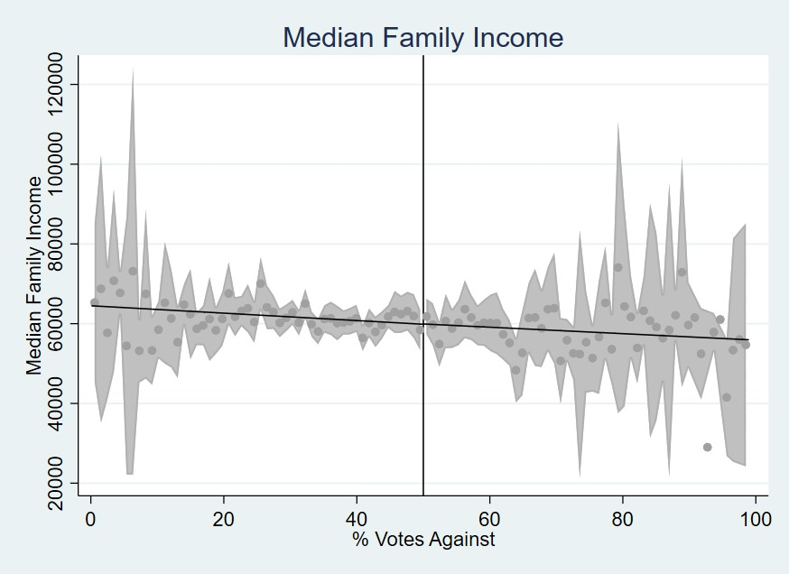
Income Heterogeneity Index Median Family Income
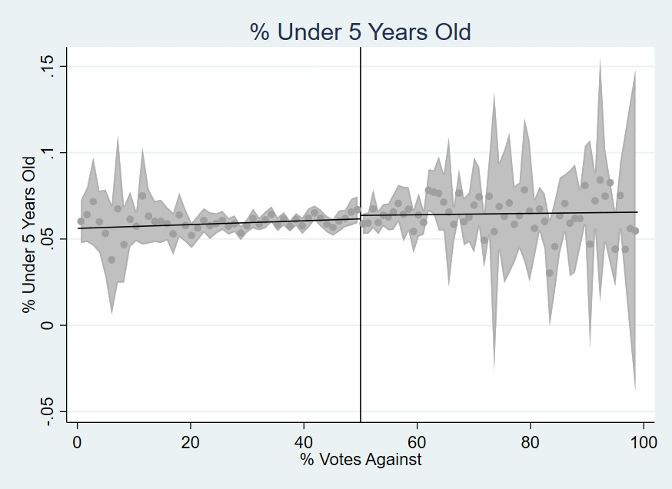
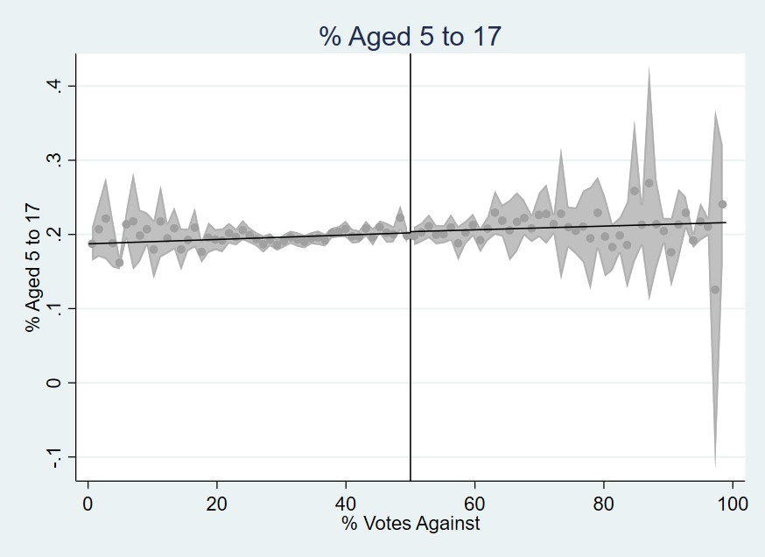
% Less than 5 years old % between 5 to 17 years
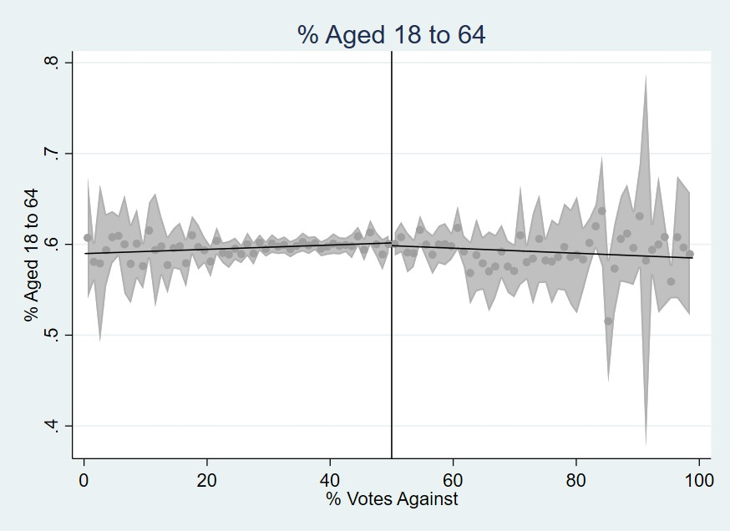
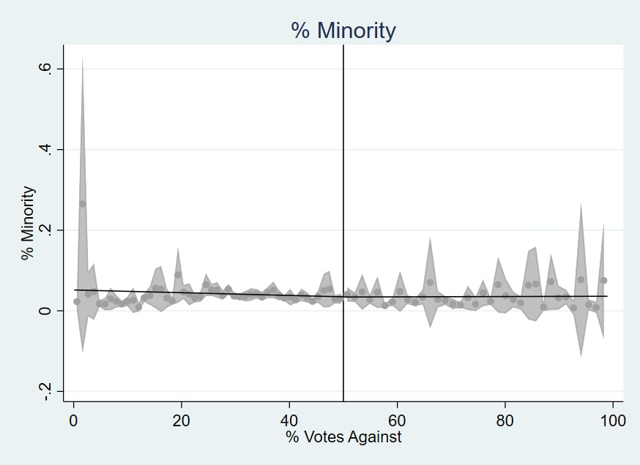

% between 18 to 64 years
52 % Minority

Figure 11: Covariate Discontinuity Plots - Part 2

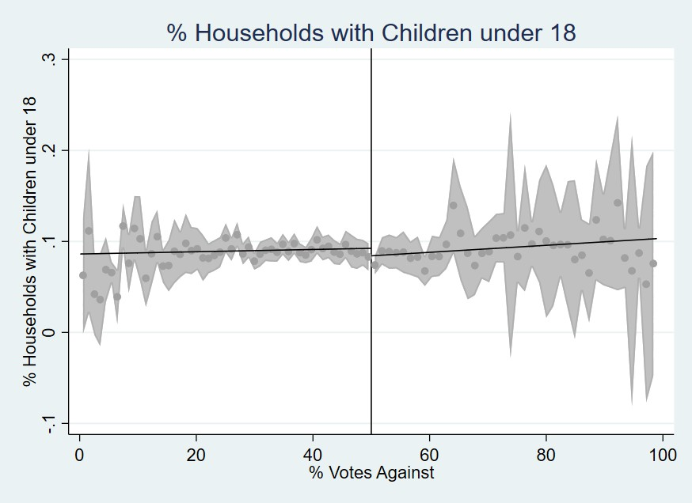

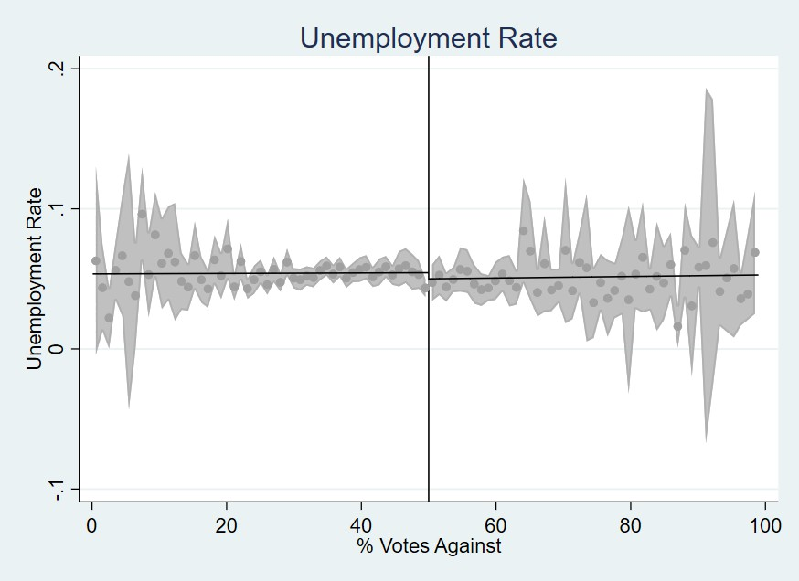
Unemployment Rate
% Households with Children 18 years old or less

Figure 12: Covariate Discontinuity Plots - Part 3

Bandwidth Sensitivity Analysis

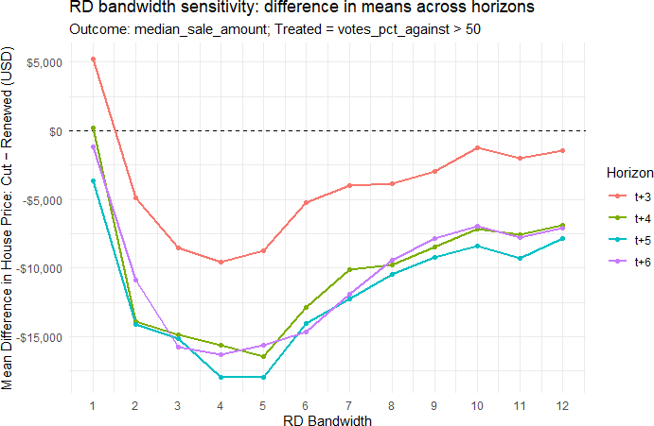

Figure 13: Bandwidth Sensitivity Analysis

Figure 13 plots the differences in mean estimate of the outcome variable, median house prices, between treated and control groups across a grid of bandwidth choices to observe how sensitive the estimates are to the choice of bandwidth. For instance, an RD bandwidth of 5 on the x-axis corresponds to including all observations within 5 percentage points of the cutoff (i.e., between 45% and 55% vote share). The y-axis shows the corresponding estimated treatment effect for that bandwidth choice. As shown, estimates are consistently negative starting year t+4 and of comparable magnitude over a broad interval around the MSERD optimal bandwidth used in the main analysis. The relative flatness of the curve near the optimal bandwidth indicates that our main result is not driven by a finely tuned bandwidth choice.

Road-Quality Vision Model: Fine-Tuning and Evaluation
In this section, we document our pipeline to classify road-surface quality from satellite imagery into three classes: poor (0), medium (1), and high (2). We begin from an ImageNet-pretrained vision model called ConvNeXt V2, available on Hugging Face and supported by Meta AI (Woo et al., 2023). We use the ConvNeXt V2 backbone and fine-tune the base version of the model on labeled road imagery from Brewer et al. (2021). The resulting model produces categorical ratings which can be converted into a continuous Road Quality Score (RQS), used in Section 4.2.

Fine-tuning Workflow. Figure 14 summarizes the end-to-end workflow. We begin with a corpus of 53,677 satellite tiles (224x224 pixels) labeled for road quality from Brewer et al. (2021). We feed these images into a ConvNeXt V2 model, replacing the original classification head with a 3-way softmax layer. We then fine-tune the entire model end-to-end using cross-entropy loss and the AdamW optimizer. The training process is monitored via a validation set, and we select the best-performing checkpoint based on minimum validation loss. Finally, we evaluate the fine-tuned model on a held-out test set to report accuracy, F1, and class-wise precision and recall.
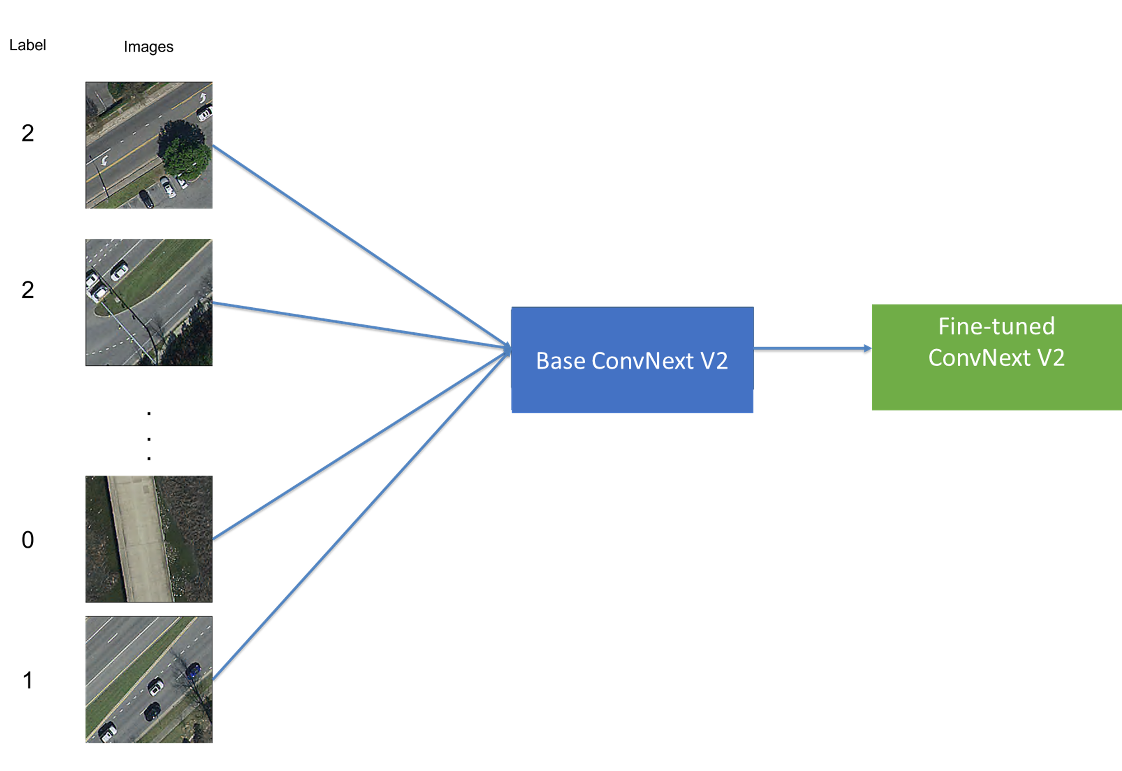
Figure 14: Fine-tuning workflow for road-quality classification

Data and Training. We fine-tune ConvNeXt V2 trained on ImageNet-1k dataset. The classification head is replaced by a 3-way softmax. We fine-tune the model for 3 epochs and use cross-entropy loss, AdamW optimizer with learning rate of 5 × 10⁻⁵ and weight decay
of 0.01, and a batch size of 16 for training and 32 for evaluation. Inputs use the model’s
ImageNet normalization; no explicit augmentation. We use a weighted, stratified 70/15/15 split and select the checkpoint with the lowest validation loss.

Split | Share | Stratified | Weights | Rationale
Train | 70% | By label | 3/2/1 | Mitigates class imbalance by allocating
 |  |  |  | more minority-class samples to training,
 |  |  |  | improving gradient signal and stability.
Validation | 15% | By label | 3/2/1 | Class-aware monitoring consistent with
 |  |  |  | “Train” split, used for model selection
 |  |  |  | (min. val. loss).
Test | 15% | By label | 3/2/1 | Hold-out evaluation with comparable
 |  |  |  | class mix for fair assessment across splits.
Table 14: Split design and class-aware allocation. Weights are used only to allocate per-class counts into splits, not as loss weights.

Model Evaluation Metrics. We report accuracy, macro F1, and class-wise precision/recall to account for any residual imbalance. We also provide a confusion matrix to diagnose systematic confusions between adjacent quality classes.
Table 15: Overall accuracy by split (fine-tuned ConvNeXt V2).

Split | Overall Accuracy
Train | 0.9115
Validation | 0.8525
Test | 0.8337

Table 16: Confusion matrix on the held-out Test set (N=1,539). Low/Medium/High correspond to classes 0/1/2.

Predicted

Low Medium High

Low | 33 | 11 | 9
Actual Medium | 12 | 78 | 181
High | 2 | 41 | 1172

Table 15 presents model accuracy results on training, validation and test datasets. Accuracy is 0.9115 on train, 0.8525 on validation, and 0.8337 on test, indicating a good fit without overfitting on training data. As expected, accuracy declines slightly from train to

Table 17: Classification metrics on the Test set derived from Table 16.

Class | Precision | Recall | F1 | Support
0 | 0.702 | 0.623 | 0.660 | 53
1 | 0.600 | 0.288 | 0.389 | 271
2 | 0.861 | 0.965 | 0.910 | 1,215
Macro avg | 0.721 | 0.625 | 0.653 | 1,539
Weighted avg | 0.810 | 0.834 | 0.810 | 1,539
Accuracy |  | 0.8337 |  | 1,539

validation to test. However, the gap between validation and test is less than 10 percentage points, suggesting good generalization across unseen data.
Table 16 shows the confusion matrix on the held-out test set and is useful to understand the types of errors the model makes when classifying road quality. As presented in the table, most errors are between adjacent classes: medium (1) is often predicted as high (2), and poor (0) occasionally as medium (1). Confusions between poor (0) and high (2) are rare, while high (2) is predominantly classified correctly.
Table 17 presents per-class metrics. Class 2 attains high precision and recall, driving weighted averages near overall accuracy, which suggests the model is very reliable at identifying high-quality roads. Class 1 shows low recall, lowering macro F1 and reflecting difficulty on borderline surfaces. This means the model often misses medium-quality roads, misclas-sifying them as high quality. Class 0 performs moderately, with balanced precision/recall relative to its smaller support, indicating reasonable reliability on poor-quality roads despite fewer examples. Overall, the model excels at identifying high-quality roads but nevertheless struggles more with medium and poor classes, especially in recall for medium quality.

Base vs. Fine-Tuned ConvNeXt V2. Table 18 summarizes the main gains from end-to-end adaptation. We compare our fine-tuned ConvNeXt V2 against a baseline where the pretrained backbone is frozen and only the classification head is trained. This linear-probe baseline on frozen ImageNet features approach is common in transfer learning.
Table 18: Fine-tuned vs. baseline ConvNeXt V2.

Model Overall Accuracy
Fine-tuned ConvNeXt V2 0.8337 Baseline ConvNeXt V2 0.2586
Fine-tuning improves test accuracy by 57.51 (from 0.2586 to 0.8337) percentage points, a more than 220% relative gain. This indicates that adapting the pretrained backbone to road imagery is crucial for learning task-specific features and achieving reliable generalization, justifying end-to-end fine-tuning over a frozen baseline.

E MVPF Calculation
As stated in Section 4.5, we use the following formula to calculate the Marginal Value of Public Funds (MVPF):

MVPF =

WTP
=
Net Cost to Government

Tax Savings - House Value Decline Direct Long Run Cost + Fiscal Externality

(5)

We combine our estimated treatment effects on house prices with expected loss in tax revenue to calculate the MVPF of road maintenance tax levies. The expected loss in tax revenue, as calculated in Table 1, is $76 per household per year. Using a capitalization rate of 5% (Hilber, 2011; Cellini, Ferreira and Rothstein, 2010), the lifetime present value of this annual tax saving is $1,520 per household, which can also be interpreted as the tax savings from cutting the renewal road tax levy. Using the standard property tax rate of 1.5% in Ohio, and the estimated decline in house prices from the tax cut in Table 4, we compute the 10-year tax base decline of $1,911, which represents the fiscal externality from cutting the road tax levy. The net cost to the government is then calculated as the direct long-run cost of $1,520 plus the fiscal externality of $1,911, totaling $3,431. The willingness to pay (WTP) is calculated as the tax savings of $1,520 minus the yearly capitalization of house price estimates over 10 years, which amounts to $6,370 per household²⁶, giving a WTP of
−$4, 850. Finally, we compute the MVPF as −$4, 850/$3, 431 = −$1.41.

²⁶This calculation is based on the idea that the house price estimate in year t reflects future disutility from decline in public amenity.

